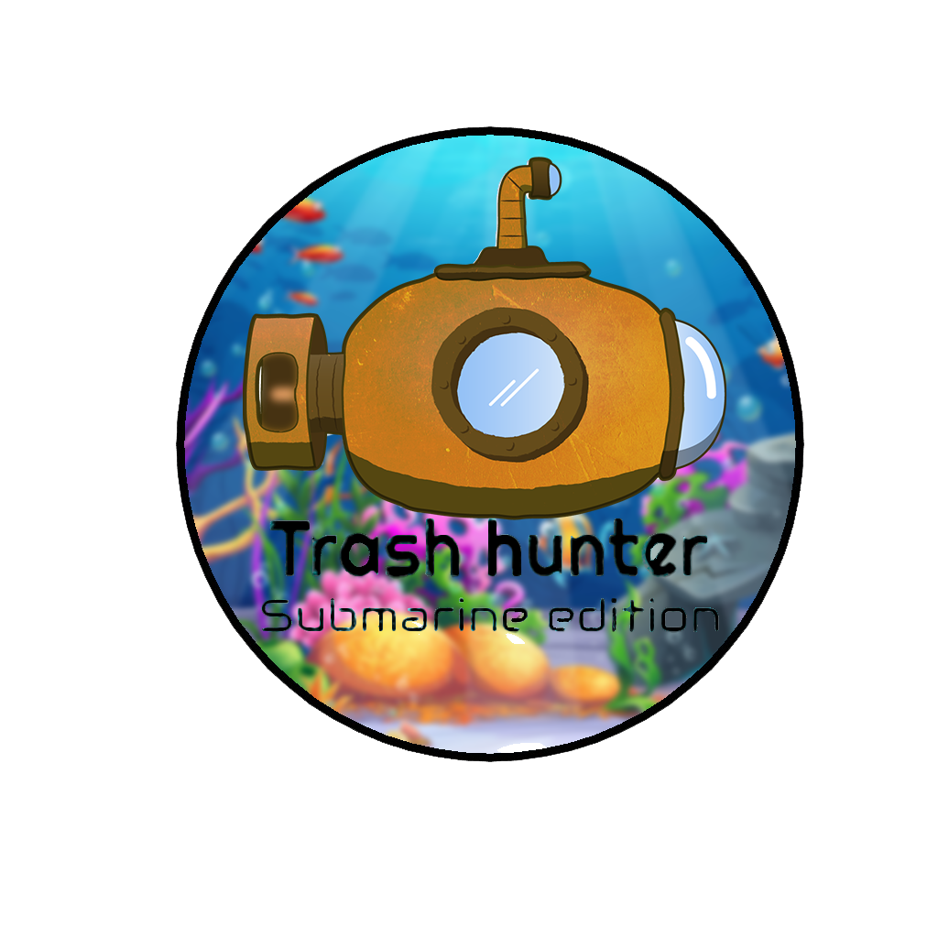

[](https://gamingqr2.netlify.app/?id=trashhunter&type=website)

**Cohort: BSE21BFT2**

**Computer**

**Game   
Programming**

**Deepvesh Hurjoon  
2110\_22797**

**Kheertik Jeetun  
2110\_22804**

**Fabrice Manikon  
2110\_22814**

**Moodita Jankoo  
2110\_22801**

**Stuart Jeetoo  
2110\_22803**

ACKNOWLEDGEMENT

We extend our heartfelt gratitude to God for the strength and guidance throughout this journey and everyone, who contributed to the success of "Trash Hunter: Submarine Edition" and the associated gaming report. Your dedication and teamwork were instrumental in shaping both the game and the analysis, creating a collaborative project.

We convey our deepest love and appreciation to our parents for their endless support and encouragement.

Special thanks to our team members for their unique contributions and commitment. Your collaborative spirit enriched the gaming experience and ensured the project's success.

We express our deep appreciation to our mentor, Mr. Riyad Dhuny, for invaluable guidance throughout the journey.

To our friends and family, thank you for your unwavering support and encouragement. Your contributions have made "Trash Hunter: Submarine Edition" a success.

Thank you to all the generous individuals and organizations who have contributed their talents and resources to design the assets making this game possible.  
  
Sincerely,

Stuart Jeetoo,

Deepvesh Hurjoon,

Manikon Fabrice.

Moodita Jankoo,

Kheertik Jeetun,

The assets from these providers were used to make our game.

Assets and packs

CRAFTPIX for “[free underwater world 2D game objects](#FreeUnderwaterWorld2dGameObject)”.

CRAFTPIX for “[free underwater world parallax game backgrounds](#FreeUnderwaterWorldParallaxBackground)”.

PngWing for free submarine [picture](#submarinepic).

FREEPICK for publishing user upklyak’s work called “[pollution sea by plastic trash, garbage underwater](#pollutionSeaByPlasticTrash)” and “[Underwater landscape with sea life animals](#underwaterLandscapeWithSeaLife)”.

OpenGameArt for publishing author Clint Bellanger’s work for “[pixel art items for a game about recycling](#ClintBellanger)”.

PngTree for publishing author weiweiwei’s work called “[black and white plastic bags](#weiweiwei)”.

Vecteezy for publishing author Matt Cole’s work called “[set of plastic trash](#MattCole1)” and “[different types of trash and trashbags](#MattCole2)”.

FREEPICK for publishing user brgfx’s work called “[a wall made of stone](#wallMadeOfStone)”, “[set granite stones isolated white](#setGraniteStonesIsolatedWhite)” and “[set of gray stones isolated on white](#setOfGrayStonesIsolatedOnWhite)”.

OpenGameArt for publishing author Brett Post Script’s work called “[PC keyboard, mouse touch input icons](#BretPostScripts)”.

Game Developer Studio for publishing artist Robert Brooks’s work called “[Dash effect](#DashEffect)” and “[Boat two](#BoatTwo)”.

PngTree for publishing user tree’s work called “[The ocean has so many trashes and plastic covered around in it background](#OceanHasSoManyTrashes)”, “[Boat is in the middle of the ocean covered with plastic and waste background](#BoatIsInTheMiddleOfOcean)” and “[Plastic items are floating in the water off of Vietnam background](#PlasticItemsFloatingInWaterViet)”.

FREEPIX for publishing user rorozoa’s work called “[Plastic waste quietly gathers in the ocean unnoticed by marine life](#rorozoa)”.

FREEPIX for publishing user jcomp’s work called “[Trash on sand beach showing environmental pollution problem](#jcomp)”.

CRAFTPIX for “[Island game – free GUI](#islandGameFreeGUI)”

Freepix for “[Free vector hand drawn animations frames element collection](#FreeVectorHandDrawn)”.

CRAFTPIX for “[Free Flame effects sprite packs](#FreeFlameEffect)”.

Sound  
User Asleep in perfection for publishing their work on YouTube called “[Peaceful underwater sounds for deep sleep, deep ocean ASMR/Ambience](#PeacefulUnderwaterSounds)”.

User Sounds of Nature and Beyond for publishing their work on YouTube called “[Relax or study with nature sounds: Waves and Gulls with 1 hr](#WavesAndSeagulls)”.

User Free Music Collection for publishing their work on YouTube called “[Water Bubble Sound Effect](#WaterBubblesSoundEffect)”.

Storyblocks for publishing a sound effect asset called “[Big Engine Start](#BigEngineStart)”, Idle of Asset ID: SBA-300024399.

Pixabay for publishing a sound effect asset called “[Motorboatsound](#Motorboatsound)”.  
  
User Infraction – No Copyright Music for publishing their work on YouTube called “[Epic Adventure Cinematic Music by Infraction [No Copyright Music] / Vega](#EpicAdventure)”.

Table of Contents

[THE BEGINNING 1](#_Toc158304780)

[COMING UP WITH IDEAS 1](#_Toc158304781)

[IDEAS 1](#_Toc158304782)

[ABOUT OUR GAME 4](#_Toc158304783)

[SUSTAINABLE DEVELOPMENT GOAL 4](#_Toc158304784)

[GAMEPLAY 4](#_Toc158304785)

[GAME PLOT 5](#_Toc158304786)

[ABOUT THE GAME 5](#_Toc158304787)

[WHY THIS IDEA? 5](#_Toc158304788)

[CORE AUDIENCE 6](#_Toc158304789)

[LEVELS & BACKGROUND 7](#_Toc158304790)

[INITIAL LEVEL DESIGN - BOAT 7](#_Toc158304791)

[INITIAL LEVEL DESIGN - SUBMARINE 8](#_Toc158304792)  
[LEVEL 1 9](#_Toc158304792)

[LEVEL 2 12](#_Toc158304793)

[LEVEL 3 13](#_Toc158304794)

[LEVEL 4 14](#_Toc158304795)

[LEVEL 5 17](#_Toc158304796)

[GAME PLOT 19](#_Toc158304797)

[GAME ASSIGNMENT 20](#_Toc158304798)

[BEHAVIORS 21](#_Toc158304799)

[GAME CHARACTERS 22](#_Toc158304800)

[SUBMARINE 22](#_Toc158304801)

[BOAT 23](#_Toc158304802)

[CLAW 24](#_Toc158304803)

[ASSETS 25](#_Toc158304804)

[TRASH 25](#_Toc158304805)

[FISH 27](#_Toc158304806)

[FISH ANIMATION 29](#_Toc158304807)

[Bubbles 30](#_Toc158304808)

[ENVIRONMENTAL OBJECTS 31](#_Toc158304809)

[TREASURE CHESTS 32](#_Toc158304810)

[SEAWEEDS 32](#_Toc158304811)

[CORALS 33](#_Toc158304812)

[GAME OBJECTS 34](#_Toc158304813)

[MINIMAP 34](#_Toc158304814)

[RADAR 35](#_Toc158304815)

[GUI 36](#_Toc158304816)

[TRASH SCORE 36](#_Toc158304817)

[PROGRESS BAR 37](#_Toc158304818)

[OBSTACLES 38](#_Toc158304819)

[STONES & CORALS 38](#_Toc158304820)

[SOUND 40](#_Toc158304821)

[WAVES & SEAGULLS 40](#_Toc158304822)

[BIG ENGINE START, RUN OFF AND MOTORBOAT SOUND 41](#_Toc158304823)

[UNDERWATER BACKGROUND AUDIO 41](#_Toc158304824)

[UNDERWATER BACKGROUND + BUBBLE SFX MIX 42](#_Toc158304825)

[EPIC ADVENTURE CINEMATIC BY INFRACTION 42](#_Toc158304826)

[GAME FEATURES 43](#_Toc158304827)

[ADMOB 43](#_Toc158304828)

[PROCESS OF ADMOB 43](#_Toc158304829)

[SINGLE SIGN ON 47](#_Toc158304830)

[GAME CONTROLS 52](#_Toc158304831)

[Game CONTROLS USED IN THE GAME 53](#_Toc158304832)

[Arrow Keys: 53](#_Toc158304833)

[BUTTONS 55](#_Toc158304834)

[GAMEPLAY BUTTONS 55](#_Toc158304835)

[SCREENS 58](#_Toc158304836)

[START SCREEN 58](#_Toc158304837)

[CREDIT SCREEN 59](#_Toc158304838)

[MOD Screen 60](#_Toc158304839)

[SETTINGS SCREEN 62](#_Toc158304840)

[SELECT LEVEL SCREEN 63](#_Toc158304841)

[MOBILE UI 64](#_Toc158304842)

[RESPONSIVE DESIGN 64](#_Toc158304843)

[TOUCH FRIENDLY CONTROLS 64](#_Toc158304844)

[BUTTONS IN THE MOBILE VERSION GAME 64](#_Toc158304845)

[GAME MOBILE & TABLET INTERFACE 67](#_Toc158304846)

[UI LEVEL COMPLETE UI LEVEL 67](#_Toc158304847)

[SCREENS 69](#_Toc158304848)

[UI CREDIT SCREEN UI 69](#_Toc158304849)

[START SCREEN UI 70](#_Toc158304850)

[SELECT LEVEL SCREEN UI 72](#_Toc158304851)

[SETTING SCREEN UI 74](#_Toc158304852)

[PAUSE SCREEN UI 76](#_Toc158304853)

[MODIFICATION SCREEN 78](#_Toc158304854)

[LEVEL 1 GAMEPLAY TUTORIAL 79](#_Toc158304855)

[SOCIAL MEDIA MARKETING WEBSITE 81](#_Toc158304856)  
[Google PlayStore 81](#_Toc158304856)

[Instagram. 84](#_Toc158304857)

[YouTube 85](#_Toc158304858)

[GAME POSTER 86](#_Toc158304859)

[REFERENCES 87](#_Toc158304860)

[IMAGE ASSETS AND PACKS 87](#_Toc158304861)

[SOUND 88](#_Toc158304862)

Figure Table

[Figure 1: Idea 1 sketch. 1](#_Toc158304863)

[Figure 2: Idea 2 sketch. 2](#_Toc158304864)

[Figure 3: Idea 3 sketch. 3](#_Toc158304865)

[Figure 4: Initial level design for boat. 7](#_Toc158304866)

[Figure 5: Initial level design for submarine. 8](#_Toc158304867)

[Figure 6: Background level 1. 9](#_Toc158304868)

[Figure 7: Submarine ejected from boat. 10](#_Toc158304869)

[Figure 8: Level 1 control tutorial. 10](#_Toc158304870)

[Figure 9: Water current implemented in level 1. 11](#_Toc158304871)

[Figure 10: Fire on level 2. 12](#_Toc158304872)

[Figure 11: Background level 2. 12](#_Toc158304873)

[Figure 12: Background level 3. 13](#_Toc158304874)

[Figure 13: Penalty bombs implemented in level 3. 14](#_Toc158304875)

[Figure 14: Background level 4. 15](#_Toc158304876)

[Figure 15: Time penalty caused by volcano to submarine. 16](#_Toc158304877)

[Figure 16: Spikes cause time penalty. 16](#_Toc158304878)

[Figure 17: Background level 5. 17](#_Toc158304879)

[Figure 18: Submarine navigating into the bonus timer. 18](#_Toc158304880)

[Figure 19: Submarine, named as Abyssal Ranger. 22](#_Toc158304881)

[Figure 20: Boat to travel the map. 23](#_Toc158304882)

[Figure 21: Claw to collect trash. 24](#_Toc158304883)

[Figure 22: All trash in a single image. 25](#_Toc158304884)

[Figure 23: Image has been imported to Illustrator for extraction. 26](#_Toc158304885)

[Figure 24: Trash has been separated. 26](#_Toc158304886)

[Figure 25: Loaded the picture of fish into photoshop. 27](#_Toc158304887)

[Figure 26: Exported fish. 28](#_Toc158304888)

[Figure 27: Animating fish in Adobe Animate. 29](#_Toc158304889)

[Figure 28: Bubbles added to submarine when navigating. 30](#_Toc158304890)

[Figure 29: Objects to be used as decoration. 31](#_Toc158304891)

[Figure 30: Treasure chest used for aesthetic. 32](#_Toc158304892)

[Figure 31: Seaweed and corals. 32](#_Toc158304893)

[Figure 32: Underground rocks. 33](#_Toc158304894)

[Figure 33: Minimap 34](#_Toc158304895)

[Figure 34: Active sonar, to localise trash. 35](#_Toc158304896)

[Figure 35: Total trash collected counter display. 36](#_Toc158304897)

[Figure 36: Timer bar depleting. 37](#_Toc158304898)

[Figure 37: Stones and corals. 39](#_Toc158304899)

[Figure 38: Proof of permission. 40](#_Toc158304900)

[Figure 39: Cutting and merging two audio, engine start and motorboat. 41](#_Toc158304901)

[Figure 40: Underwater and bubble merged into one audio. 42](#_Toc158304902)

[Figure 41: Ad unit, types of ads and ads ID (Interstitial Ads) 44](#_Toc158304903)

[Figure 42: Statistics earning for the last 28 days. 44](#_Toc158304904)

[Figure 43: Creating and loading of Advert (Blurred due to security reasons). 45](#_Toc158304905)

[Figure 44: Final & Working Advertisement on mobile. 45](#_Toc158304906)

[Figure 45: Proof of account. 46](#_Toc158304907)

[Figure 46: Final release for internal testing. 48](#_Toc158304908)

[Figure 47: Close testing. 49](#_Toc158304909)

[Figure 48: Releases overview. 50](#_Toc158304910)

[Figure 49: Keymapping overview. 52](#_Toc158304911)

[Figure 50: Controls used to navigate the submarine. 54](#_Toc158304912)

[Figure 51: Game Buttons. 55](#_Toc158304913)

[Figure 52: Play button. 56](#_Toc158304914)

[Figure 53: Credit button. 56](#_Toc158304915)

[Figure 54: Settings button. 57](#_Toc158304916)

[Figure 55: Mod button. 57](#_Toc158304917)

[Figure 56: Start Screen 58](#_Toc158304918)

[Figure 57: Credit Screen. 59](#_Toc158304919)

[Figure 58: Mod Screen 61](#_Toc158304920)

[Figure 59: Settings Screen. 62](#_Toc158304921)

[Figure 60: Select Level Screen 63](#_Toc158304922)

[Figure 61: Drop submarine button. 64](#_Toc158304923)

[Figure 62: Board back on boat button. 65](#_Toc158304924)

[Figure 63: Grab on trash button. 65](#_Toc158304925)

[Figure 64: Analog control button. 66](#_Toc158304926)

[Figure 65: Slider to control claw. 66](#_Toc158304927)

[Figure 66: Level complete. 68](#_Toc158304928)

[Figure 67: Credit Screen UI on phone. 69](#_Toc158304929)

[Figure 68: Start Screen UI on tablet. 71](#_Toc158304930)

[Figure 69: Select level screen UI on mobile. 73](#_Toc158304931)

[Figure 70: Settings Screen UI on tablet. 75](#_Toc158304932)

[Figure 71: Pause screen UI on phone. 77](#_Toc158304933)

[Figure 72: Modification screen UI in tablet. 78](#_Toc158304934)

[Figure 73: Level 1 boat tutorial on phone. 79](#_Toc158304935)

[Figure 74: Level 1 submarine tutorial on tablet. 80](#_Toc158304936)

[Figure 75: Sustainable Development Goal Game website. 81](#_Toc158304937)

[Figure 76: Itch.io Browser game. 82](#_Toc158304938)

[Figure 77: Google PlayStore (Unreviewed) 82](#_Toc158304939)

[Figure 78: Facebook account for our game. 83](#_Toc158304940)

[Figure 79: Instagram account for our game. 84](#_Toc158304941)

[Figure 80: YouTube Channel for our game. 85](#_Toc158304942)

[Figure 81:Game poster 86](#_Toc158304943)

# 

# THE BEGINNING

## COMING UP WITH IDEAS

For this project, our focus was on the area of Sustainable Development, leveraging the educational aspect of gaming to raise awareness and educate the players on the different global challenges that exist.

### IDEAS

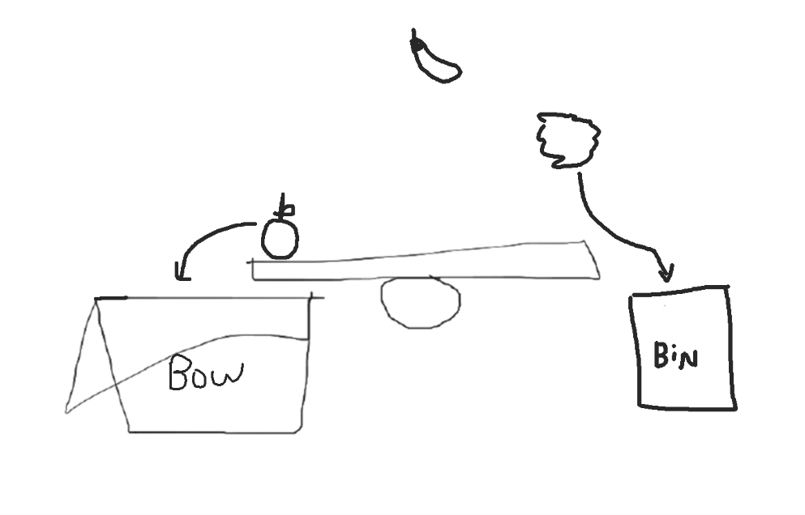Our first idea was based on gender equality and partly on recycling. It was about a cooking game, where the player could have either a male or female character. The player was given different food recipes to work with and had to filter the food or vegetables from the trash. The food stuff goes into a bowl or plate while the trash is disposed into different recycle bins according to their materials by using a seesaw with physics for separation. Furthermore, the players would have the ability to cook food by making use of the ambient light sensor on the device to regulate the cooking fire. That is the strong light will cook faster, however, the food might get burned. On the other hand, low light will take more time to cook. We wanted to implement that part to make the game more challenging and not too mundane.

Figure 1: Idea 1 sketch.

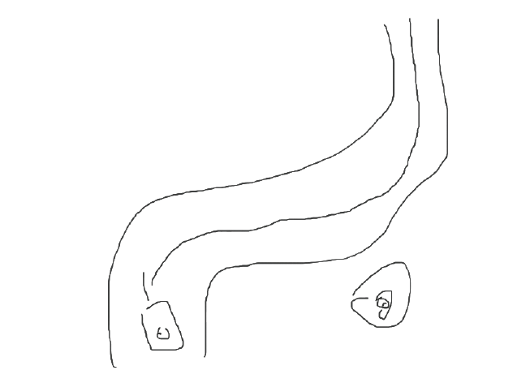Our second idea was based on reducing air pollution caused by fuel driven vehicles. The players would have an electric car to race against bots on a racing track, with diverse obstacles to make the game entertaining. We were thinking to implement mobile sensor such as accelerometer to control the car.

Figure 2: Idea 2 sketch.

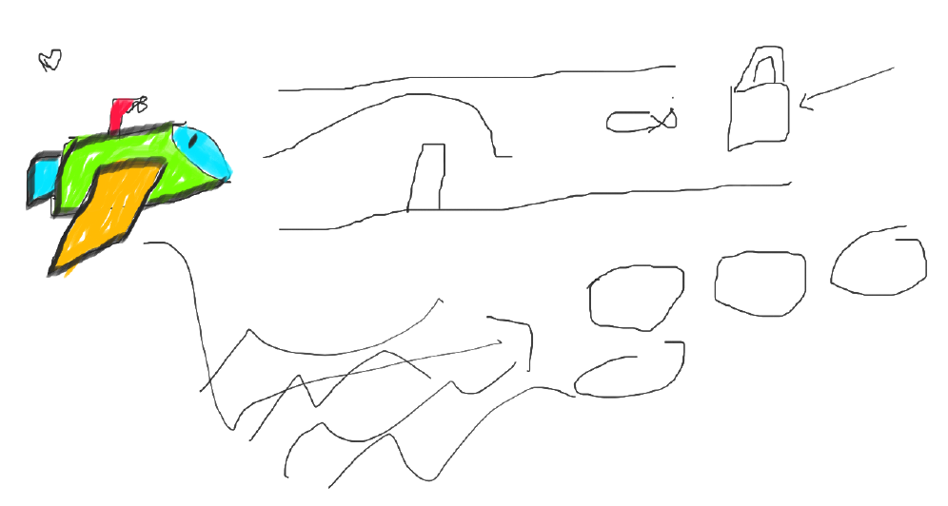And finally for our third idea, we thought about marine life and its ecosystem. It is estimated about 14 tons of wastes produced by human end up in the ocean yearly. The player will be commanding a submarine with a clamp navigating through mazes and avoiding obstacles, to collect trash using a claw. We thought to create an infinite level the main objective would be to collect all the trash before a timer runs out and will be rewarded with additional time when collecting trash.

Figure 3: Idea 3 sketch.

# ABOUT OUR GAME

## SUSTAINABLE DEVELOPMENT GOAL

My team and I had to choose the most impactful out of the three ideas, we decided to go with the submarine one. Marine pollution resulted in a lot of marine life death as the animal either consumed the plastics or got entangled into debris. Additionally, humans being the driving factor of so many deaths are also affected, as consuming seafoods in polluted water is hazardous to human health. Hence, our objective is to use the power of gaming to teach players about the devastating impact pollution has on marine life and to inspire them to take action to protect the ocean and its beautiful ecosystem. In Trash Hunter, you are a submarine Commander willing to contribute to the fight against sea pollution. Into the depths, where silence speaks louder than words!

## GAMEPLAY

Trash Hunter: Submarine Edition is an immersive gaming experience crafted to elevate awareness of ocean pollution and instill sustainable behavior in players. The game unfolds with Abyssal Ranger (The Submarine) as the central character, leading a Trash Hunt. As the submarine navigates through polluted underwater landscapes, it will discover the consequences of neglect and the importance of responsible waste management, recycling, and ocean conservation.

After the players eject the submarine from the boat, they be able to control the submarine and dive into the deep blue sea, navigating through underwater landscapes to capture and remove debris using a claw. As they collect trash, players must return to the boat for an additional time boost otherwise the timer runs out and players will fail the mission. With each successful retrieval, players will gain time boost and the collected trash can later be used for upgrades to improve the boat, claw, and submarine speed. Together, we can save the ocean and protect its delicate ecosystem for generations to come.

## GAME PLOT

In the not-so-distant future, the world's oceans are drowning in pollution, and marine life is on the brink of extinction. Governments and environmental organizations have come together to form the Oceanic Cleanup Initiative, deploying advanced submarines equipped with cutting-edge technology to combat the rising tide of trash. As an elite member of the Trash Hunter squadron, you are tasked with piloting the most advanced submarine, the "Abyssal Ranger," to explore the darkest depths of the ocean and clean up the mess humanity has left behind.

## ABOUT THE GAME

"Trash Hunter: Submarine Edition" combines immersive gameplay with environmental education. As Submarine, players navigate ocean depths, collecting trash and overcoming obstacles. The game seamlessly integrates garbage collection and recycling themes, using unique in-game currencies to teach players about environmental sustainability. The choices made in the game impact both the storyline and the virtual ocean environment, encouraging players to adopt more sustainable behaviors. Ultimately, the game provides an engaging experience that inspires real-world actions for a cleaner, healthier ocean ecosystem.

WHY THIS IDEA?  
Games like "Trash Hunter: Submarine Edition" fall within the serious game’s genre, aiming to influence behavior rather than solely entertain. This form of gameplay serves as a tool for promoting social change, conducting research, facilitating education, and enabling scientific discovery. By emphasizing ecology, such games can delve into the economic, humanitarian, and societal dimensions of environmentalism, offering a holistic exploration of the challenges and opportunities in fostering environmental awareness and sustainability.

CORE AUDIENCE  
"Trash Hunter: Submarine Edition" is designed to capture a broad audience, especially those with an interest in environmental sustainability and awareness. With its focus on garbage management and recycling, paired with interactive and captivating gameplay, "Trash Hunter: Submarine Edition" appeals to both children and adults. The game not only entertains but also serves as an educational tool, imparting valuable lessons about the importance of environmental sustainability and the consequences of pollution.

**Target Audience:**

Age Group: 7 – 15 years old

Gender: Male & Female

# LEVELS & BACKGROUND

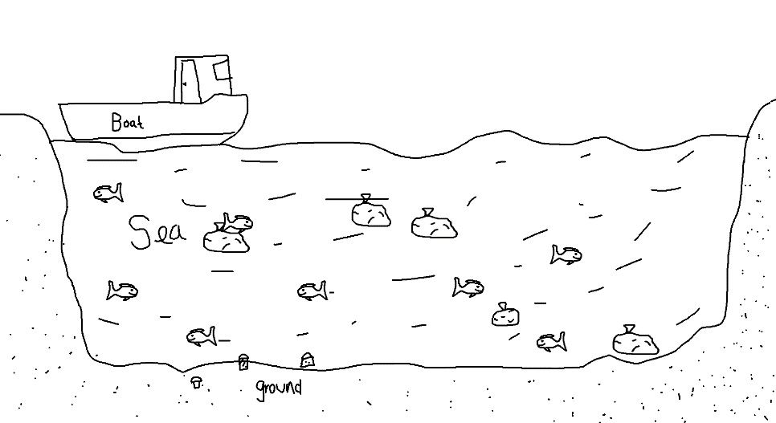INITIAL LEVEL DESIGN - BOAT  
The level starts with a boat floating on the sea, the player will be able move the boat left or right and will be able to eject the submarine anywhere the players want to in the map. While controlling the boat, the player will not be able to interact with trash and the timer will be paused.

Figure 4: Initial level design for boat.

## INITIAL LEVEL DESIGN - SUBMARINE Once the player ejects the submarine from the boat, the timer starts. The player’s mission is to collect trash within 5 minutes time limit. The player will have to use the claw to grab the trash and then return to the boat to be rewarded with additional time bonus. Additionally, the total number of trashes collected can be used to purchase modifications to improve boat, submarine, and the submarine’s claw speed.LEVEL 1

Figure 5: Initial level design for submarine.

Level 1 of "Trash Hunter: Submarine Edition" immerses players in a peaceful and scenic beach area. The background is basic yet appealing, with golden beaches running along the shoreline and meeting the serene, azure water. The constant ebb and flow of mild waves creates a relaxing atmosphere, which improves the entire game experience.

The sun casts a warm warmth over the area, and the sky above is painted in gentle blues and subtle oranges, evoking the atmosphere of a serene seaside day. Palm palms wave in the mild breeze, lending a tropical feel to the environment. The basic design of the background allows players to focus on the game's core elements—cleaning up the ocean—in this visually appealing and soothing environment.

As players navigate through the first level, the simple yet aesthetically beautiful beach view serves as a wonderful backdrop, setting the stage for the immersive voyage that lies ahead in "Trash Hunter: Submarine Edition.

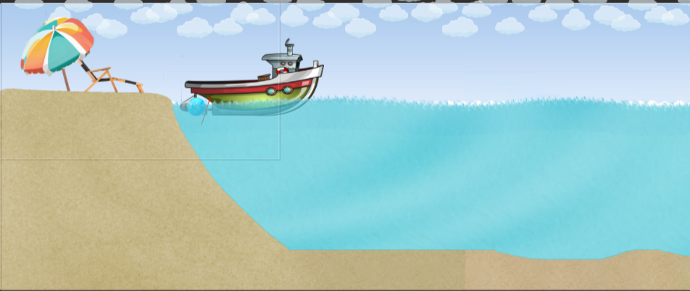

Figure 6: Background level 1.

After the submarine has been ejected, a new HUD appears, and the player will be able to take the helm and explore the map.

*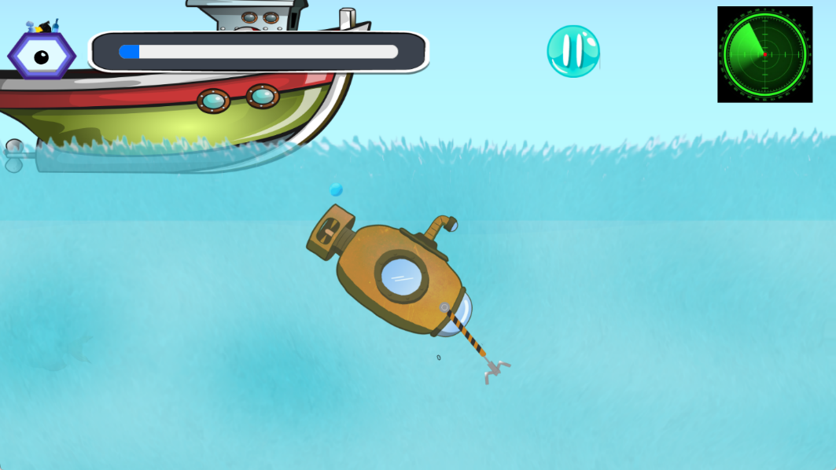*  
Additionally level one focuses on teaching the player how to navigate the submarine while exploring the map using different controls. After the player got familiar with the controls, the tutorial will end, and the player will be able to play the level normally.

Figure 7: Submarine ejected from boat.

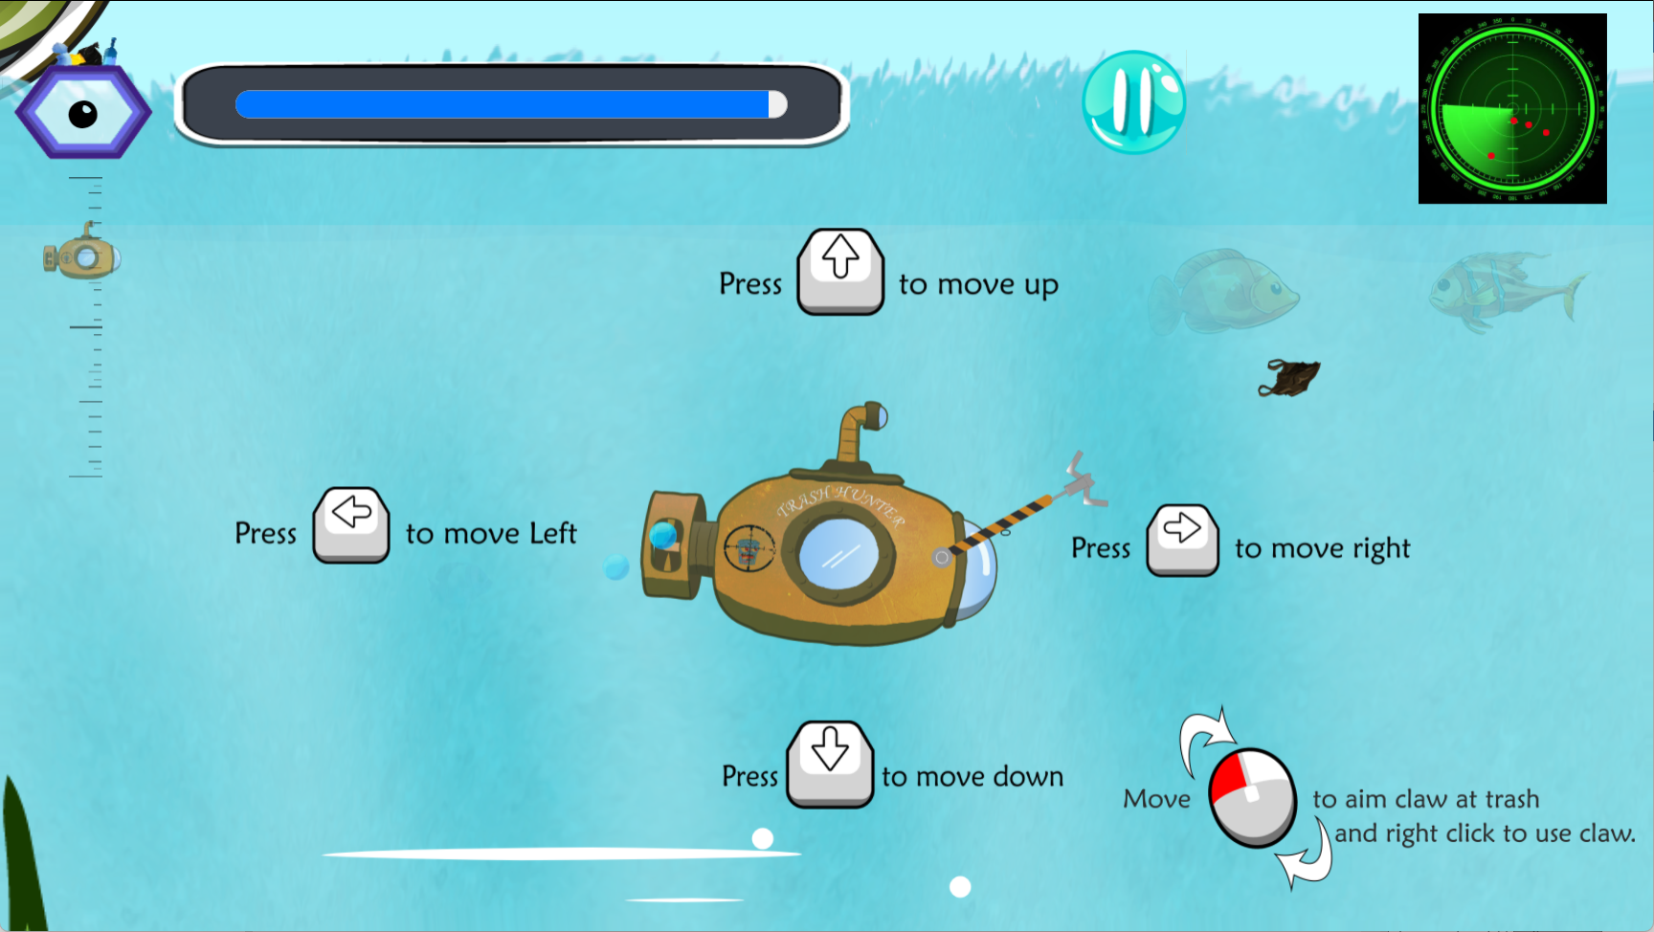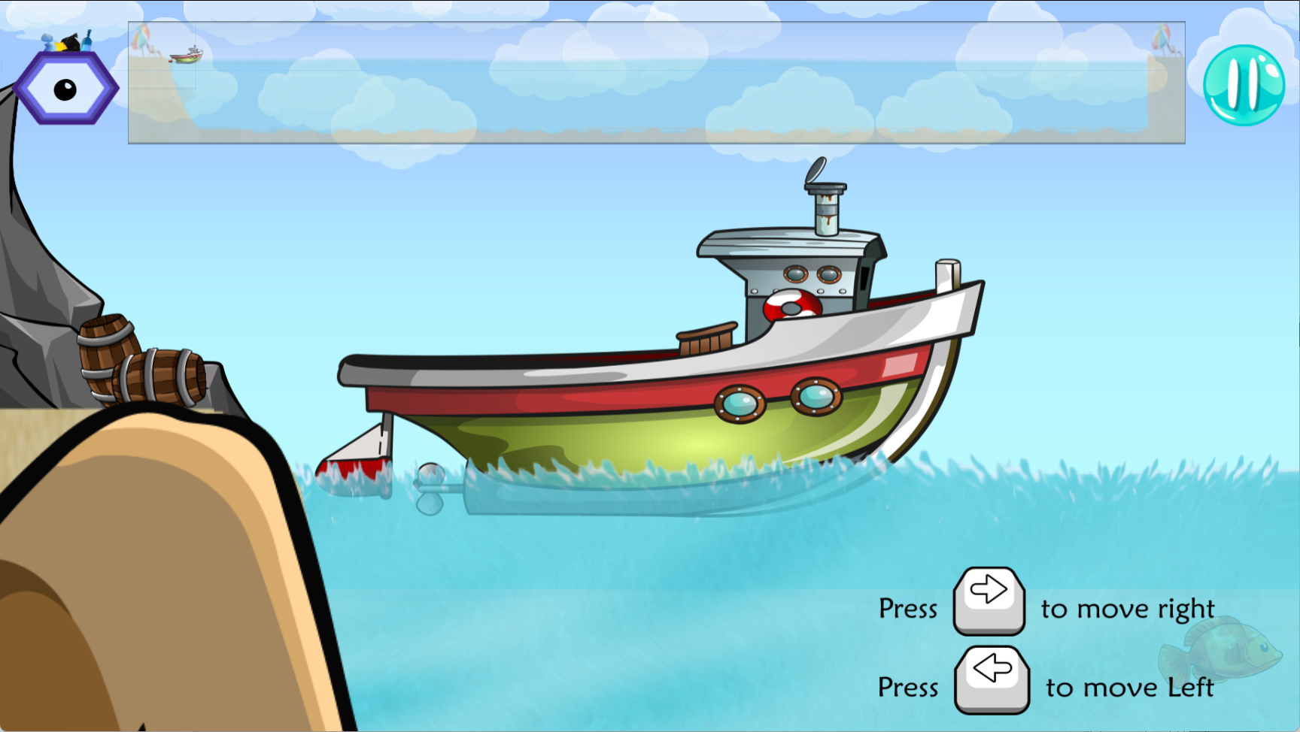

Figure 8: Level 1 control tutorial.

For level 1, Kheertik’s contribution to his level was a water current. It was implemented to make the level more challenging, however, it can also work in favour of the player. As the submarine approaches the right direction of the water current, the submarine will be propelled forward giving a temporary boost aiding the player to collect trash faster. However, if the submarine got in the wrong direction of the current, the player won’t be able to pass through or maybe even trapped inside as it can turn into a vortex making the player lose precious time and can only get out by building momentum.

Figure 9: Water current implemented in level 1.

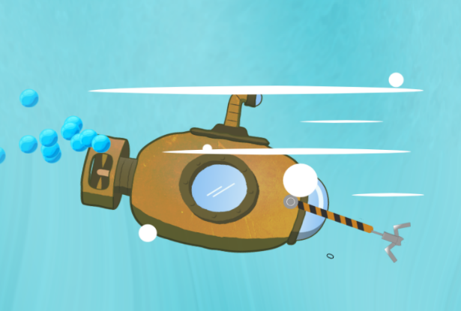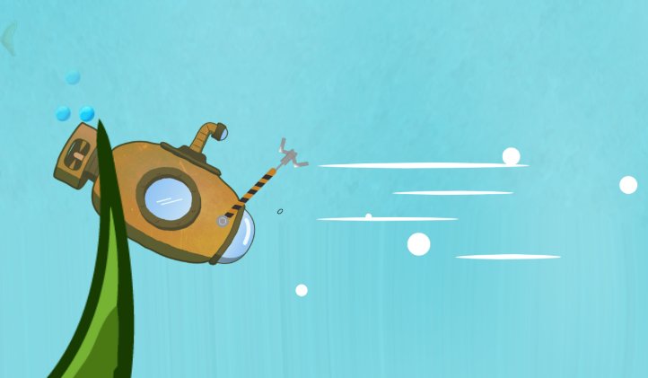

## LEVEL 2

Level 2 of "Trash Hunter: Submarine Edition" takes players to a radiant and visually magnificent sea environment, complete with flowing seaweed and strewn stones. The peaceful atmosphere sets the tone for an enjoyable gaming experience.

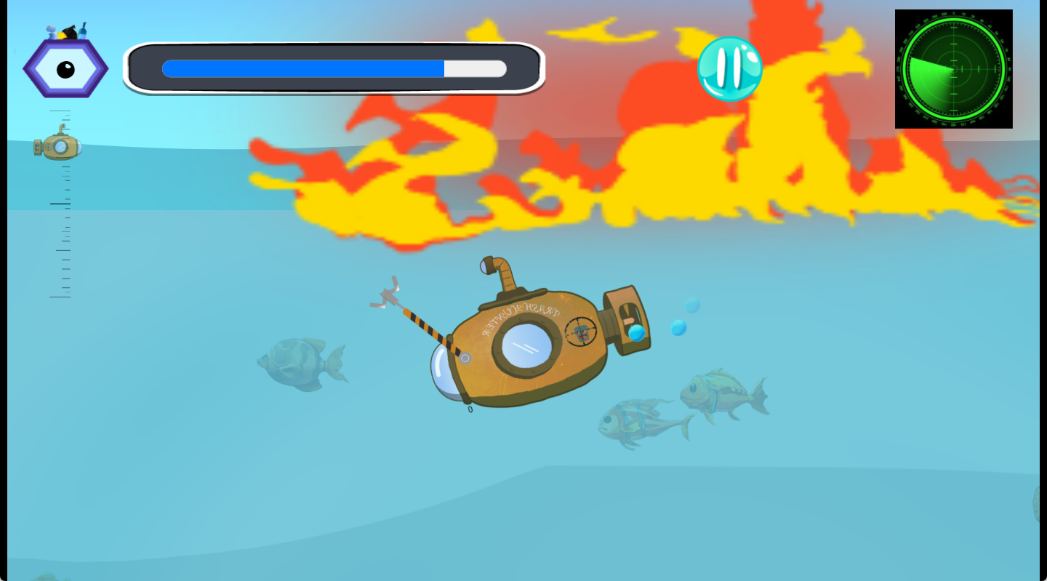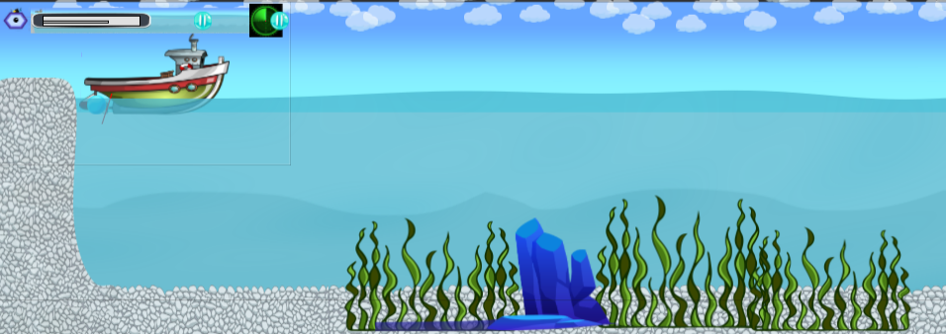  
  
This level introduces a new dynamic with the addition of a difficult element: fire. As players cruise the bright sea, they must carefully dodge the dangerous flames that threaten the Abyssal Ranger submarine and will slow it down. The addition of this obstacle adds a degree of strategy, pushing players to maneuver carefully and test their talents in the face of adversity.

Figure 10: Fire on level 2.

Figure 11: Background level 2.

## LEVEL 3

Level 3 in "Trash Hunter: Submarine Edition" features a similar but subtly altered landscape. The placid sea background retains its relaxing attractiveness, now enhanced by the presence of soft, sandy expanses intermingled with scattered boulders. The combination of sand and rocks adds nuanced diversity to the underwater landscape.

As players proceed through Level 3, they will guide the Abyssal Ranger submarine through this balanced environment, where the sandy seabed provides a smoother passage and the rocks present strategic difficulties. The harmonic cohabitation of sand and rocks adds visual interest while also diversifying the gameplay experience, forcing players to adjust their methods accordingly.

With the subtle sway of aquatic plants and the play of light on the ocean floor, Level 3 remains an immersive and delightful backdrop for the ongoing ocean cleanup work. This level demonstrates the game's design adaptability, providing players with a dynamic and exciting experience set against a tranquil and familiar sea backdrop.

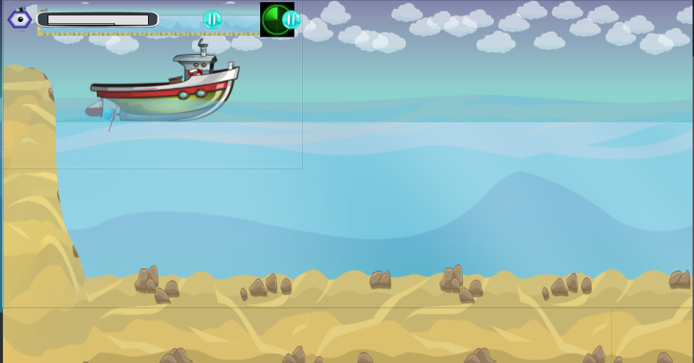

Figure 12: Background level 3.

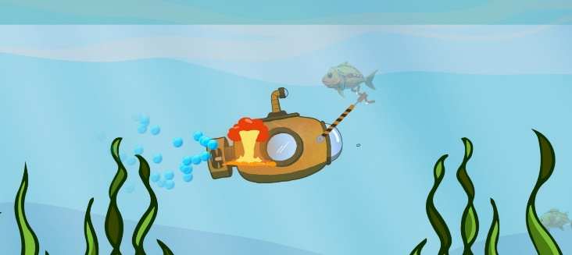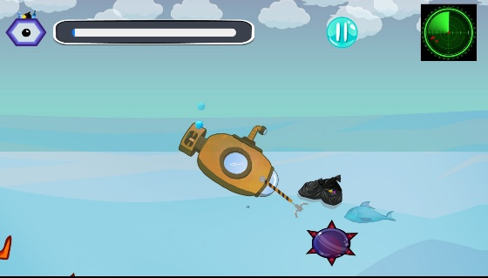For level 3, Fabrice introduced penalty bombs to intensify the challenge. When the submarine collides with one, players incur a 10-second time penalty. This feature adds a strategic element, requiring precision and urgency to avoid setbacks. Balancing speed and caution become crucial, keeping players engaged until the final moments, where efficient trash collection is paramount to success.

## LEVEL 4

Figure 13: Penalty bombs implemented in level 3.

Level 4 of "Trash Hunter: Submarine Edition" transports players to the depths of the ocean, giving a wide and expansive setting characterized by the secrets of the deep. The tranquil blue expanse stretches into the distance, creating an immersive scene that foreshadows a transition into deeper waters.

This level's ocean floor has a sense of depth, with basic yet captivating images that capture the essence of the deep sea. The subtle play of light and shadows lends mystery to the undersea location, resulting in a serene yet awe-inspiring ambiance.

Navigating through Level 4 needs players to face the perils of the deep sea while remaining focused on the primary goal of cleaning up the virtual ocean environment. The shift to the underwater depths adds a new level to the game, providing players with a visually rich and engaging experience in "Trash Hunter: Submarine Edition."

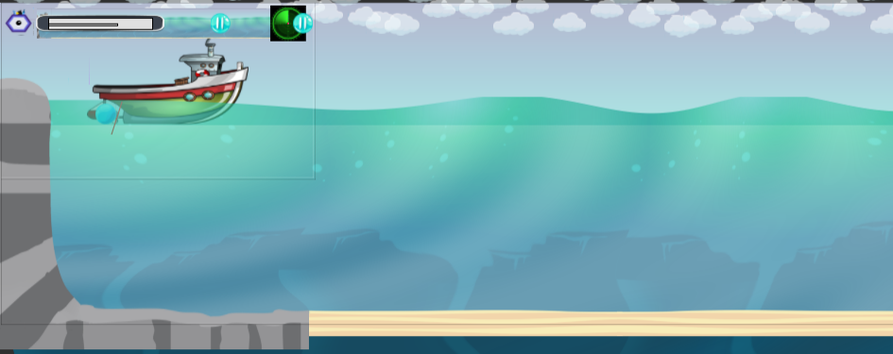

Figure 14: Background level 4.

For level 4, Deepvesh’s contribution was adding an underwater volcano. As the submarine comes close to the volcano, it turns red, causing the time to decrease by 10 seconds. Moreover, there is smoke and bubbles coming out from the volcano. If the submarine touches the smoke, the time will decrease by 20 seconds. Furthermore, near the end of the level, there will be another small volcano with lava. If the submarine touches it, there will be a deduction of 20 seconds from the time.

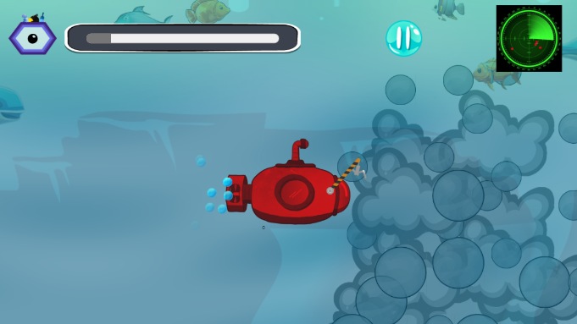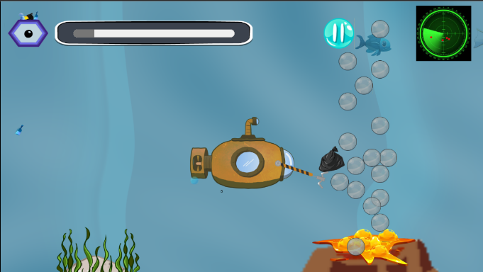

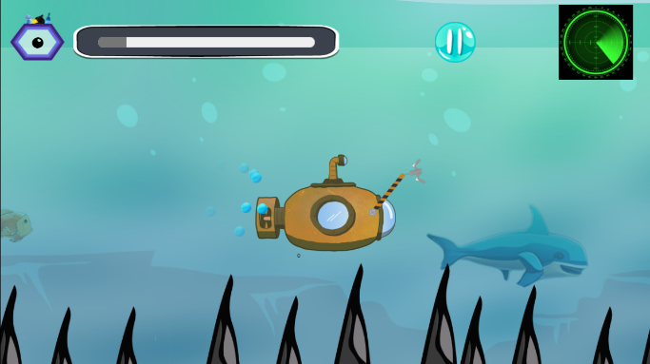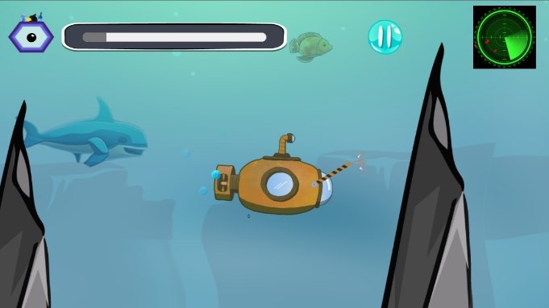  
  
Additionally sharp, spike-like rocks have been implemented. If the submarine touches any of them, there will be a deduction of 5 seconds.

Figure 15: Time penalty caused by volcano to submarine.

Figure 16: Spikes cause time penalty.

## LEVEL 5

In "Trash Hunter: Submarine Edition," Level 5 features a vivid and lively undersea spectacle. The sea background comes to life with a color explosion, displaying a vast array of marine life as well as vivid seaweed swaying with the gentle currents. This level provides a visually exciting and dynamic setting, in stark contrast to the simplicity of the previous levels.

The abundance of colorful seaweed adds a dynamic and whimsical element to the ocean floor, resulting in a vibrant underwater world brimming with life. Schools of fish smoothly flow across the screen, bringing movement and excitement to the beautiful seascape. The use of vibrant colors and marine life improves the overall aesthetic appeal, providing players with a visually stimulating experience as they continue their task of cleaning up the ocean.

Level 5 concludes the gaming experience in "Trash Hunter: Submarine Edition," presenting players with a stunning and satisfying visual backdrop as they navigate through this vivid and dynamic underwater area.

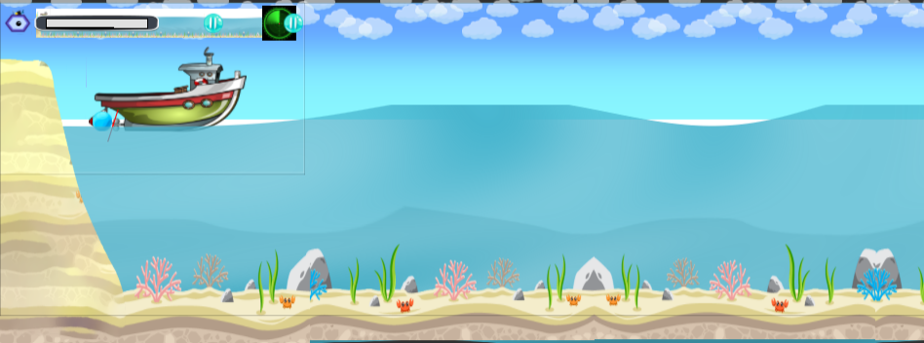

Figure 17: Background level 5.

Stuart’s contribution for level 5, he used a timer clock as an asset, when the player navigates the submarine into the timer, the player is rewarded with an addition of 10 seconds to timer progress bar.  
  
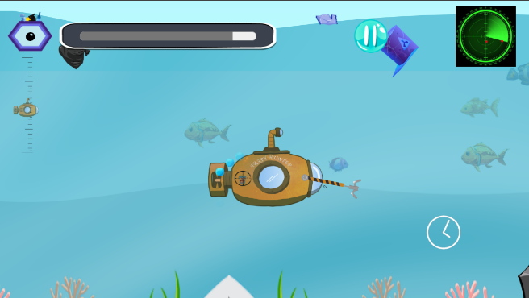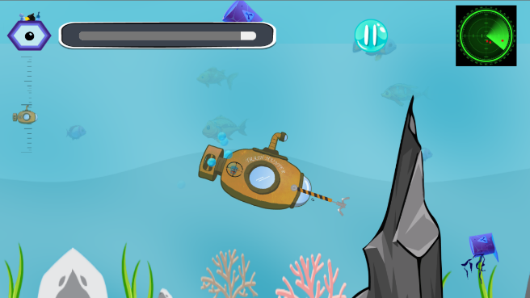

Figure 18: Submarine navigating into the bonus timer.

# GAME PLOT

In the immersive adventure "Trash Hunter: Submarine Edition," players take on the role of brave underwater explorers on a mission to rid the seas of rubbish. Armed with a cutting-edge submarine, players descend into the ocean's depths, navigating difficult underwater terrains to catch and destroy garbage. Through this interactive trip, players learn about the devastating effects of pollution on marine life, highlighting the crucial need of ocean conservation.

**Game Genre:** Physics Game

**Theme:** Pollution & Recycling

**Title:** Trash Hunter – Submarine Hunter

**Choice of Background:** We tried to portrait every aspect of the ocean, the radiant beach, marine life, and the polluted ocean.

**Game Obstacles:** Stones

**Main Character:** The submarine can collect a total of 40 trash and put it on a boat.

**Game Platform:** Mobile & Web

# GAME ASSIGNMENT

Each team member brought their distinct skills and knowledge to "Trash Hunter: Submarine Edition," resulting in a cohesive and exciting gaming experience.

**Kheertik:** Led the implementation of spawning trash randomly, which added a sense of unpredictability to the game. In addition, emphasis was placed on animating fish to improve the underwater environment. Kheertik performed an important role in creating Level 1, which laid the groundwork for the player's quest.

**Deepvesh:** led the submarine's modification, providing unique elements to improve gameplay. I worked on backend functionality to ensure that the game's interactions were flawless. I also took control of Level 4, which added to the variety of play scenarios.

**Stuart:** Used knowledge to improve submarine movement, making it more responsive and intuitive for gamers. Crafted Level 5 demonstrates innovation in developing a visually appealing and demanding gaming environment.

**Fabrice:** Implemented Single Sign-On feature to streamline the player login process. AdMob has been integrated into the game to enable successful monetization techniques. Fabrice's contributions ensured a mix of user convenience and financial viability.

**Jhanvy:** oversaw designing the start screen, which served as an intriguing entry point into the game. Contributed to backend functionality, resulting in smooth interactions. Additionally, played an important role in developing Level 2, which introduced obstacles and strategic components to the gameplay.

# BEHAVIORS

* Physics:
  + Simulates realistic objects physics, powered by Box2D.
* Platformer:
  + Jump and run along platforms (solid/jump-thru objects).
* Sine:
  + Adjusts an object’s position, size and angle or other properties with oscillating sine wave.
* Solid:
  + Make an object impassable, so other objects cannot move or fall through it.
* Pin:
  + Stick to another object maintaining a relative distance and angle.
* Fade:
  + Change an object’s opacity over time.
  + Useful for making objects gradually disappear.
* Bounded drag and drop:
  + A drag and drop with a limited X and Y axis.
* Scroll To:
  + Always center the view on this object, or at the mid-point of multiple objects.

# GAME CHARACTERS

## SUBMARINE

The Abyssal Ranger in "Trash Hunter: Submarine Edition" is a well-developed component that complements the game's environmental task. This submarine shows a commitment to advanced technology and sustainability, with a streamlined design, strengthened alloys, and cutting-edge vacuum systems that symbolize strength and dedication.

In contrast to traditional game creation, in which characters are meticulously drawn to fit physical qualities and skills, the Abyssal Ranger is a dynamic asset in the game. Its translucent viewport adds to the immersive experience by giving players a visual link to the aquatic world while also emphasizing the game's environmental awareness.

The Abyssal Ranger, like characters in games, evolves with the player's progress, earning upgrades and boosting capabilities. Incorporating recycling technology into its functioning emphasizes the company's dedication to appropriate environmental practices, making it an important and dynamic aspect in the story and message of "Trash Hunter: Submarine Edition." This component is essential not only for gaming, but also for conveying the overarching message of pollution prevention and ocean protection.



Figure 19: Submarine, named as Abyssal Ranger.

## BOAT

In "Trash Hunter: Submarine Edition," the dedicated support boat is an important part of the ocean cleanup effort. The boat acts as a deployment and recovery hub for the Abyssal Ranger submarine, providing a strategic link between the ocean's surface and the depths below.

Each mission begins with the boat releasing the Abyssal Ranger into the ocean, indicating the start of the cleanup operation. As the submarine carefully collects a significant amount of rubbish, it surfaced and transferred the accumulated debris to the waiting support boat. This symbiotic interplay enables the efficient disposal and recycling of accumulated garbage.

Figure 20: Boat to travel the map.

## CLAW

In "Trash Hunter: Submarine Edition," the Abyssal Ranger submarine features a specific claw mechanism at the front of its sleek look. This cutting-edge claw is the key equipment for effectively gathering floating debris and rubbish from the ocean depths.

As the submarine travels through dirty waters, players can manipulate the claw to scoop up and secure various forms of debris. The easy controls allow for precision trash targeting and retrieval, stressing the necessity of accuracy and strategic maneuvering during the cleanup process.

This claw mechanism not only improves the gameplay experience by introducing an interactive element, but it also represents the submarine's active environmental protection efforts. This technology underscores the submarine's duty as a loyal guardian, tirelessly striving to clear the ocean of pollution in "Trash Hunter: Submarine Edition."

Figure 21: Claw to collect trash.

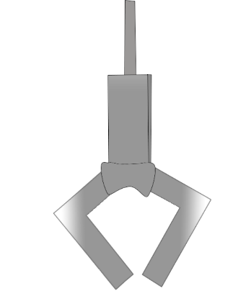

# ASSETS

## TRASH

In "Trash Hunter: Submarine Edition," the ocean is littered with a wide variety of garbage, from normal litter to hazardous waste. This virtual sea of rubbish, which floats on the surface and spreads across the ocean floor, poses a huge threat to marine life and the delicate balance of the underwater ecosystem.

Players may meet a variety of garbage, including plastic bottles, discarded containers, rusting metals, and other contaminants, each with its own unique features. The visual portrayal of rubbish is both realistic and varied, emphasizing the gravity of the pollution situation throughout the game's plot.

As players maneuver the Abyssal Ranger submarine through dirty seas, their purpose is to collect and eliminate pollutants using the claw mechanism. Successful retrieval helps to the goal of cleaning the ocean, while also providing a concrete portrayal of the real-world issues associated with ocean conservation in "Trash Hunter: Submarine Edition."

Figure 22 shows that all the trash was in a single picture, and each item have been individually extracted using Adobe Illustrator.

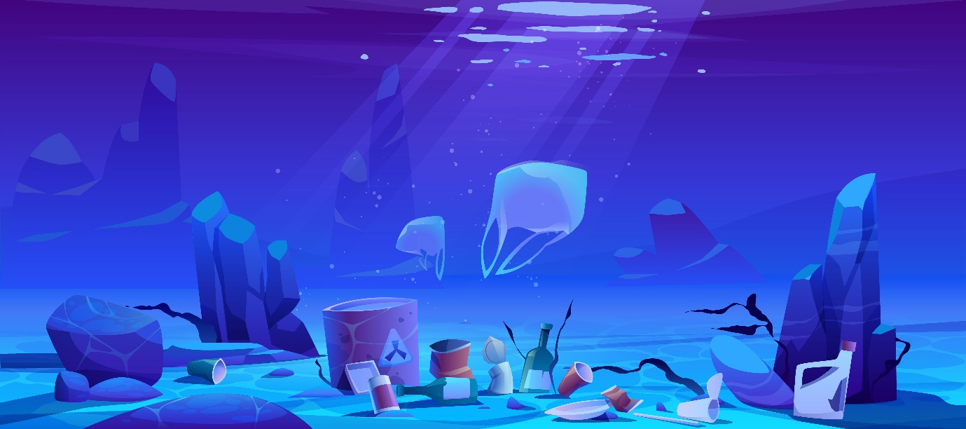The image has been imported into the library and the irrelevant layers were hidden, then the assets were transformed to fit the canvas layout for later use.  
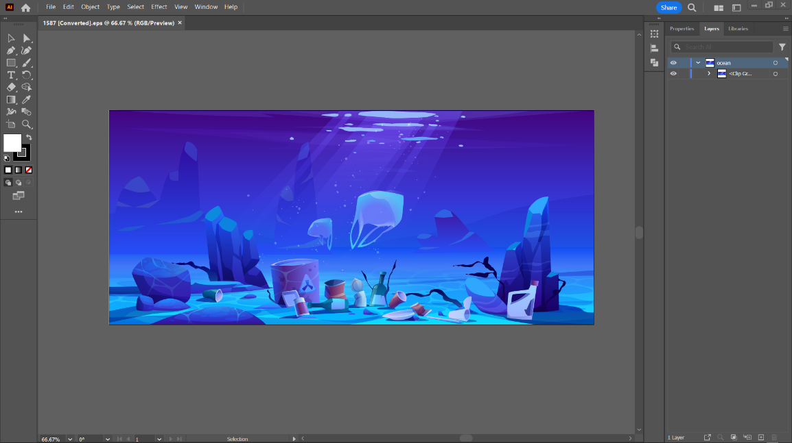

Figure 22: All trash in a single image.

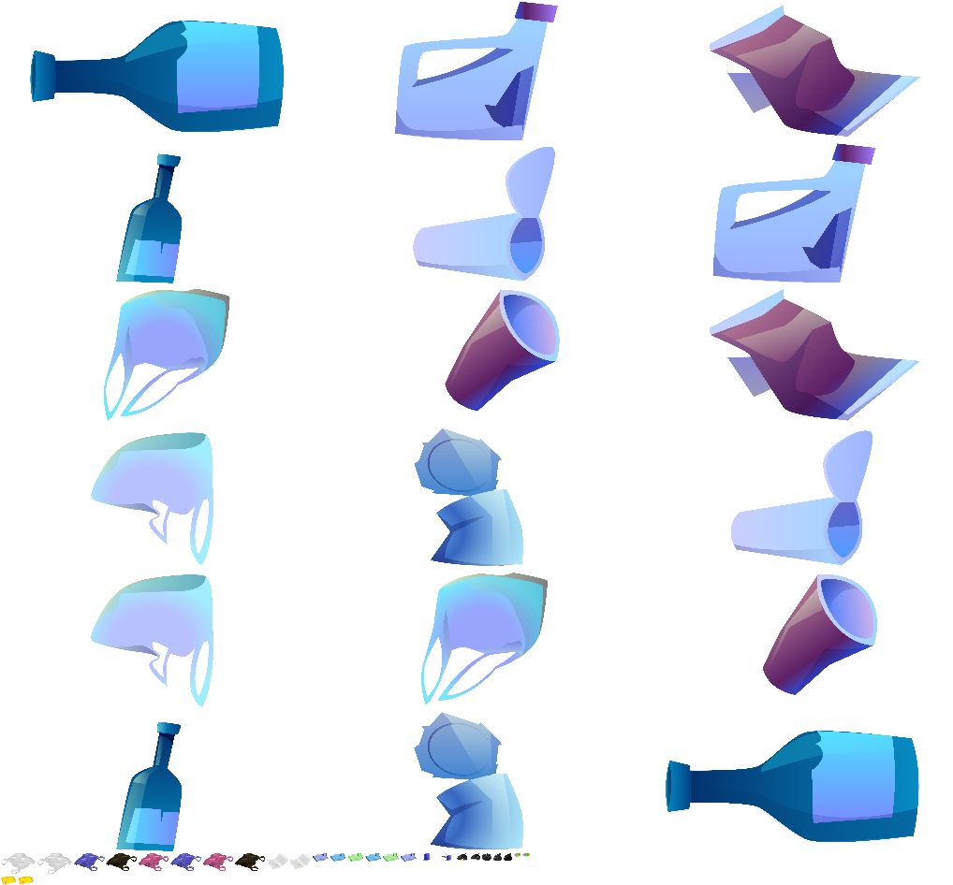  
Figure 24 shows the different trash that was extracted and converted into a sprite sheet.

Figure 23: Image has been imported to Illustrator for extraction.

Figure 24: Trash has been separated.

## FISH

In "Trash Hunter: Submarine Edition," the incorporation of diverse fish species adds to the game's visual appeal and realism, creating a more immersive undersea setting. These artificial aquatic residents add to the game's overall attractiveness, bringing the undersea world to life with brilliant colors, sophisticated movements, and a variety of marine behaviors.

As players pilot the Abyssal Ranger submarine through polluted seas, they are treated to a graphically spectacular and dynamic picture of marine life, including schools of tropical fish, gorgeous underwater creatures, and elusive deep-sea inhabitants. The incorporation of these fish not only provides visual value, but also demonstrates the interconnectedness of the ocean ecosystem.

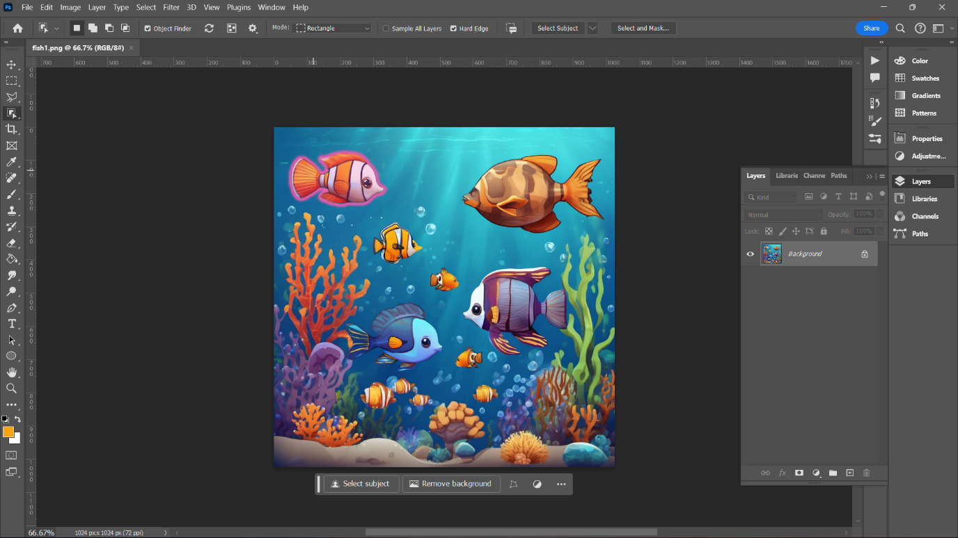The fish in the game contribute significantly to the virtual environment's realism, reflecting the delicate balance of life beneath the waves. Their existence adds complexity to the story, underlining the importance of protecting the ocean not only for the purpose of cleaning up rubbish, but also for the survival of the various marine life in "Trash Hunter: Submarine Edition." Figure 25 shows the picture was loaded into the library of photoshop.

Figure 25: Loaded the picture of fish into photoshop.

The picture of fishes has been imported in Photoshop library and then dropped into the canvas. The magic wand and object selection tool were used to separate the fishes from the background with utmost precision and then separated into different layers. Furthermore, each individual fish was transformed to match the canvas size to be later used and was then exported.

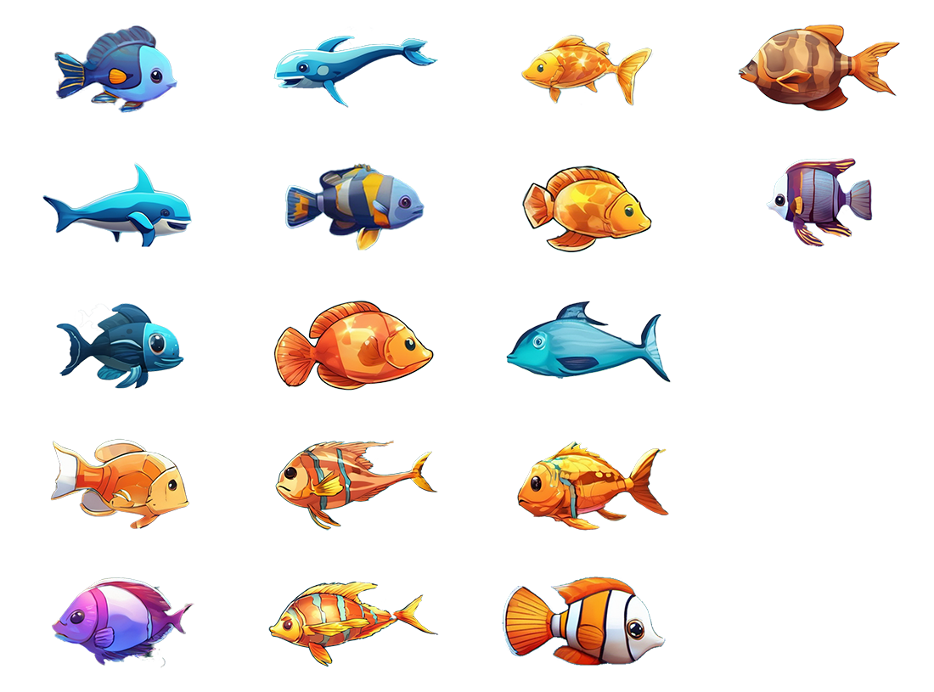

Figure 26: Exported fish.

### FISH ANIMATION

All the exported fishes were imported into Adobe Animate library to be animated individually. The pin tool provided great help to animate the fishes easily to make it increase the immersiveness of the game. Figure 27 shows the layer 1 has been embedded with frames, and classical tween have been applied to it.

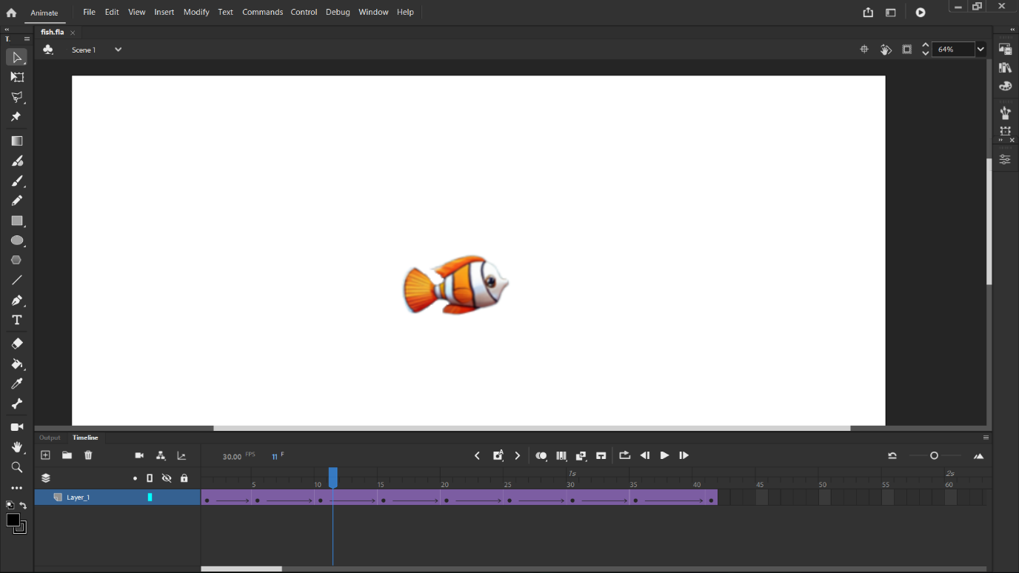

Figure 27: Animating fish in Adobe Animate.

## Bubbles

In "Trash Hunter: Submarine Edition," the incorporation of moving bubbles provides a lovely and realistic touch to the game, contributing to its overall visual splendor and immersive depiction of the aquatic environment.

As players guide the Abyssal Ranger submarine through the underwater world, the abundance of bubbles provides a visually appealing atmosphere. These moving bubbles not only give a dynamic aspect to the environment, but they also convey a sense of life and movement within the ocean depths.

The bubbles represent the brightness and vigor of aquatic ecology, in addition to being aesthetically pleasing. This graphic detail, which depicts the natural occurrence of bubbles in the ocean, adds to the game's realism, giving players a more authentic and compelling experience.

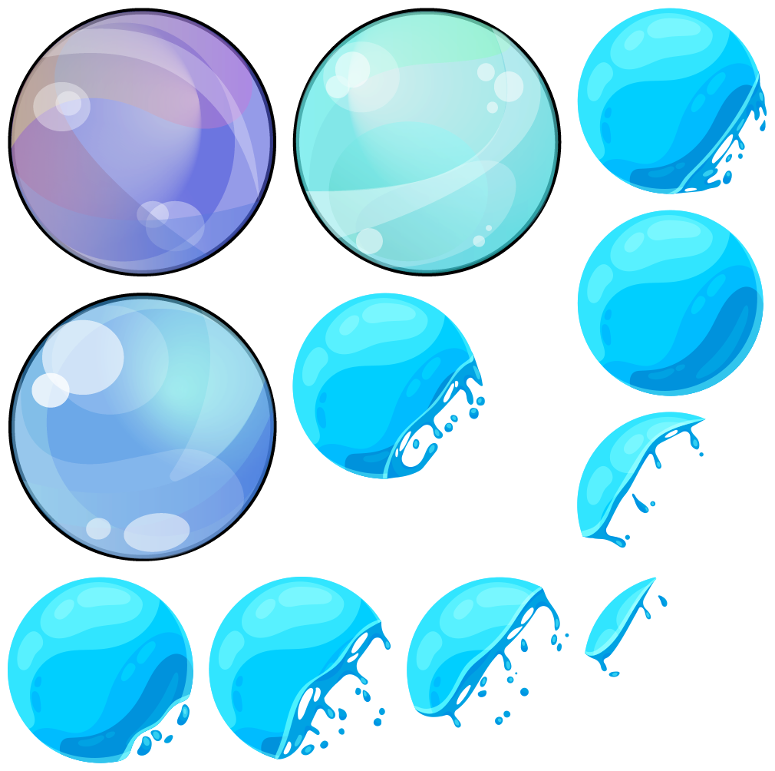In essence, the bubbles in "Trash Hunter: Submarine Edition" play a subtle but important part in making the gaming world more attractive and realistic. They add to the overall aesthetic appeal by immersing players in a visually spectacular portrayal of the ocean and reaffirming the game's commitment to providing an interesting and realistic gaming environment.

Figure 28: Bubbles added to submarine when navigating.

# ENVIRONMENTAL OBJECTS

In the enthralling realm of "Trash Hunter: Submarine Edition," players come across a wide range of ambient objects that serve not only as decorations but also as essential aspects of the undersea landscape. These artifacts offer depth and visual complexity to the water environment, resulting in a more immersive gameplay experience.

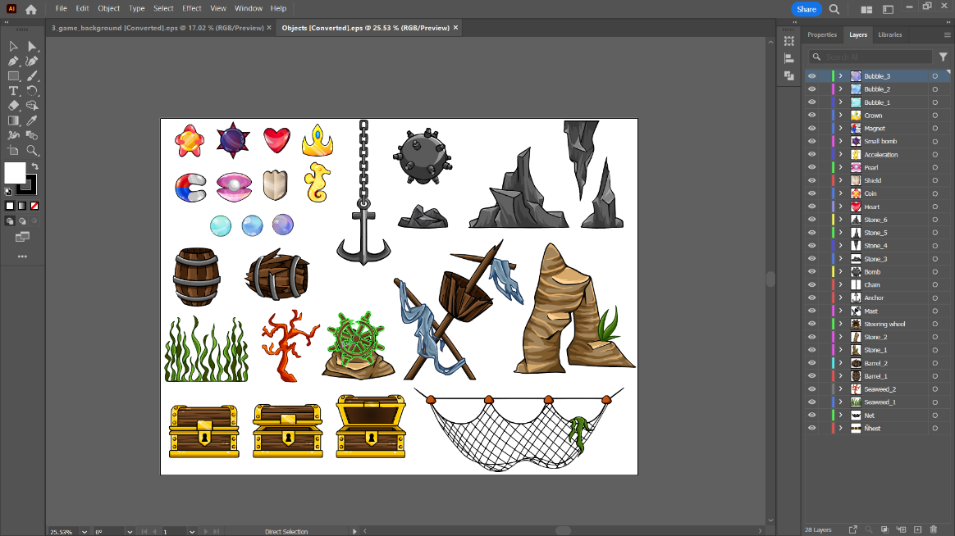

Figure 29: Objects to be used as decoration.

## TREASURE CHESTS

Each treasure box is carefully placed to evoke a sense of adventure and discovery. As players move across the aquatic environments, the ornamental treasure boxes serve as subtle focal points, tempting them to explore the complexities of the underwater world. Although they do not provide prizes, their inclusion adds an element of aesthetic appeal and interest to the gaming experience.



Figure 30: Treasure chest used for aesthetic.

## SEAWEEDS

Seaweeds are graceful and brilliant, and they move with the underwater currents, adding to the ocean floor's visual liveliness. These ornamental components not only enhance the looks, but also create a more realistic and captivating aquatic habitat. Players can navigate among these aquatic plants, adding elegance to their quest.

Figure 31: Seaweed and corals.

## CORALS

Corals: Delicate and colorful corals adorn the ocean floor, offering both decorative and environmental purposes. These corals not only enhance the game's visual richness, but they also serve as interactive elements. Players may need to navigate around or through coral formations, adding a strategic element to the gameplay.



Figure 32: Underground rocks.

These environmental artifacts in "Trash Hunter: Submarine Edition" are more than just decorations; they are meticulously constructed features that enhance the gameplay. Whether it's the thrill of discovering treasure chests, the elegant movement of seaweed, or the strategic navigation around corals, these elements add to the overall immersion and enjoyment of the underwater environment that players explore.

# GAME OBJECTS

## MINIMAP

In "Trash Hunter: Submarine Edition," the minimap appears as an important navigational aid, dynamically indicating the support boat's movements and strategic maneuvers. This feature not only improves gameplay, but it also gives players real-time information on the overall mission dynamics.

As the support boat travels through the water, the minimap shows its location, trajectory, and current actions. This visual representation allows players to anticipate the boat's location, which aids strategic decision-making for the Abyssal Ranger submarine. Whether the boat is moving to a new cleanup zone or waiting for the submarine to return with gathered trash, the minimap acts as a useful guide, keeping players informed and involved throughout the gameplay experience.

The inclusion of the minimap adds to the game's user-friendly interface by allowing players to seamlessly coordinate their activities with the movements of the support boat. This addition not only improves practical functionality, but it also emphasizes the sense of teamwork and coordination required for the ocean cleanup mission in "Trash Hunter: Submarine Edition."



Figure 33: Minimap

## RADAR

In "Trash Hunter: Submarine Edition," the radar system appears as a critical technology that improves the gameplay experience by giving players with a full tracking mechanism for the Abyssal Ranger submarine. This new feature adds to the game's strategic depth and immersion by allowing players to navigate the polluted waters with accuracy and efficiency.

The radar continuously analyzes the submarine's position, motions, and surroundings in real time. It shows important information including local debris, potential hazards, and the overall geography of the ocean floor. This graphic representation provides players with crucial insights that aid in decision-making as they navigate the submarine through various difficulties and cleanup zones.

As the submarine collects rubbish and navigates through various places, the radar becomes an essential tool for strategic planning. It assists players in determining optimal paths, locating certain sorts of debris, and avoiding potential impediments, making the cleanup mission more efficient and enjoyable.

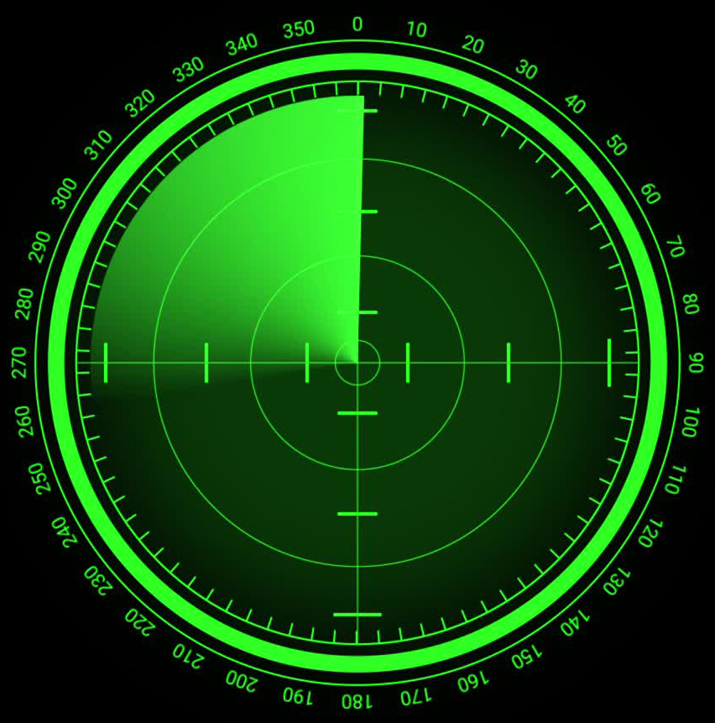The incorporation of the radar system not only adds realism to the gameplay, but it also emphasizes the role of technology in environmental conservation. By seamlessly integrating radar into the game mechanics, "Trash Hunter: Submarine Edition" provides players with a more immersive and strategic experience as they work to protect the ocean ecology.

Figure 34: Active sonar, to localise trash.

# GUI

## TRASH SCORE

In "Trash Hunter: Submarine Edition," the score bar is a critical component, methodically calculating the total number of trash objects collected by the Abyssal Ranger submarine. This dynamic element not only counts the player's contribution to the cleanup task, but it also turns gameplay into a measurable and gratifying experience.

As players navigate the filthy waters, each correctly recovered piece of garbage adds to the growing total displayed on the scoreboard. This real-time feedback mechanism gives players a vivid and tangible depiction of their efforts to reduce ocean pollution.

The cumulative nature of the score bar adds a degree of difficulty and motivation, motivating players to strive for better totals and mastery in their cleanup efforts. Watching the score rise provides as a visual representation of the player's dedication to environmental conservation in the simulated ocean environment.

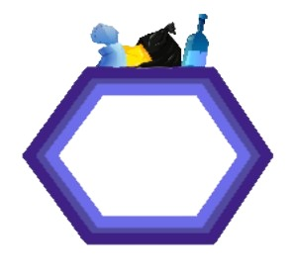In essence, the score meter in "Trash Hunter: Submarine Edition" is more than just a number indicator; it's a dynamic tool that boosts player engagement, giving them a sense of achievement as they actively contribute to making the ocean a cleaner and healthier environment in the game world.

Figure 35: Total trash collected counter display.

## PROGRESS BAR

In "Trash Hunter: Submarine Edition," the inclusion of a progress bar enhances the gaming experience by giving players a visual depiction of the game's duration. This dynamic element serves as a guide, providing updates on the general progress and timeframe of the ocean cleanup project.

As the players begin their undersea adventure, the progress meter progressively advances, symbolizing the passage of time throughout the game. This visual cue allows players to measure their pace, estimate the remaining time, and strategically plan their activities to optimize their impact on cleanup efforts.

The progress bar is not simply a temporal indication, but also a technique for maintaining a sense of urgency and excitement during gameplay. As the bar fills, players are encouraged to efficiently cruise the ocean depths, gather rubbish, and complete their objectives before the mission ends.

To summarize, the progress bar in "Trash Hunter: Submarine Edition" is an important feature that improves the whole gaming experience. By giving players a clear sense of time progression, the game becomes more immersive and interesting, allowing players to successfully manage their efforts during the ocean cleanup mission.

Figure 36: Timer bar depleting.

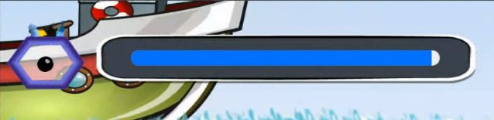

# OBSTACLES

## STONES & CORALS

In "Trash Hunter: Submarine Edition," the undersea environment is not only dense with garbage, but it also poses unique obstacles in the form of stones and corals. These natural components provide another degree of difficulty to the action, forcing players to travel carefully to avoid obstructions.

Stones of varied sizes and location create strategic bottlenecks through which players must successfully navigate the Abyssal Ranger submarine. These obstacles put the player's precision and control to the test, highlighting the importance of strategic thought to avoid collisions and travel properly while cleaning up rubbish.

Corals, with their elaborate and often brittle structures, serve as both visually beautiful and demanding challenges. Players must manage these sensitive ecosystems to avoid damage and maintain the game's environmental commitment. This feature not only adds challenge to the game, but it also emphasizes the need of maintaining and protecting maritime habitat.

The addition of stones and corals as barriers enhances the gameplay experience in "Trash Hunter: Submarine Edition." It converts the ocean environment into a dynamic and demanding place in which players must balance effective trash collecting with precise navigation to complete their task of cleaning up the virtual underwater world.

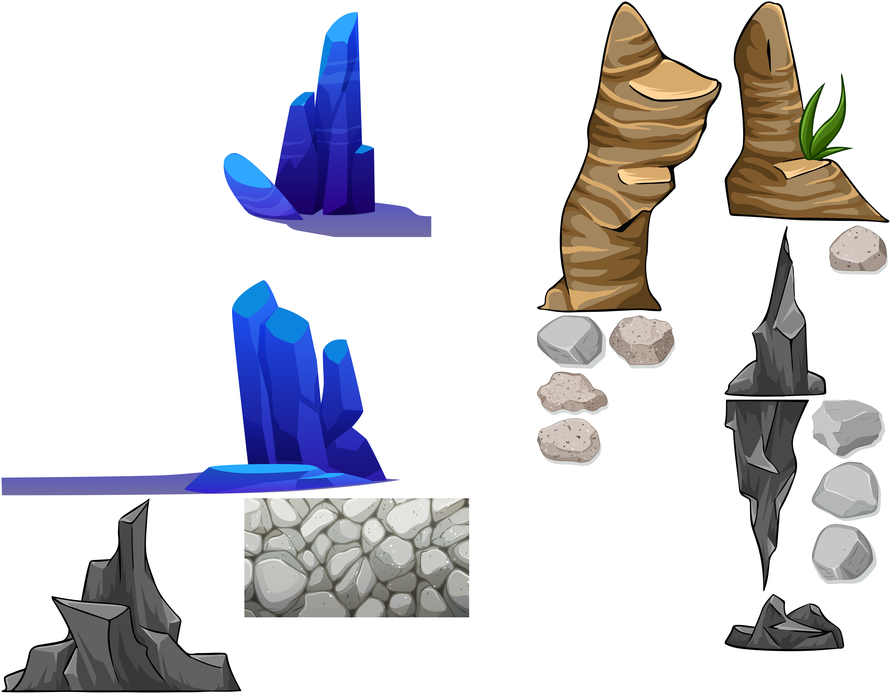

Figure 37: Stones and corals.

# SOUND

The soundscape is vital in providing an immersive and compelling game experience. The carefully designed audio elements contribute to the overall mood, providing depth and realism to the undersea environment.

Please note that a permission was obtained from the owner to utilize the sonar sounds as example.

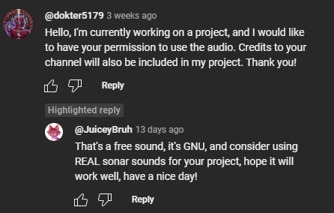

Figure 38: Proof of permission.

[WAVES](https://www.youtube.com/watch?v=HKmEWRZNJ3k) & SEAGULLS  
This sound plays on the starts screen, giving off the player a vibe of warmness and relaxation.

BIG ENGINE START, RUN OFF AND MOTORBOAT SOUND  
To make the game more immersive, when the starts playing on any layer, the boat engine sound cue starts, playing a sound of the engine starting. Once the engine has started, players will be able to move and as the speed of the boat increases, the engine rev audio will also increase. Furthermore, this will give the player a realistic feeling when commandeering the boat. The two audio engine start and motorboat sound were merged into one. Furthermore, the gain of motorboat was reduced to simulate the boat being idle.

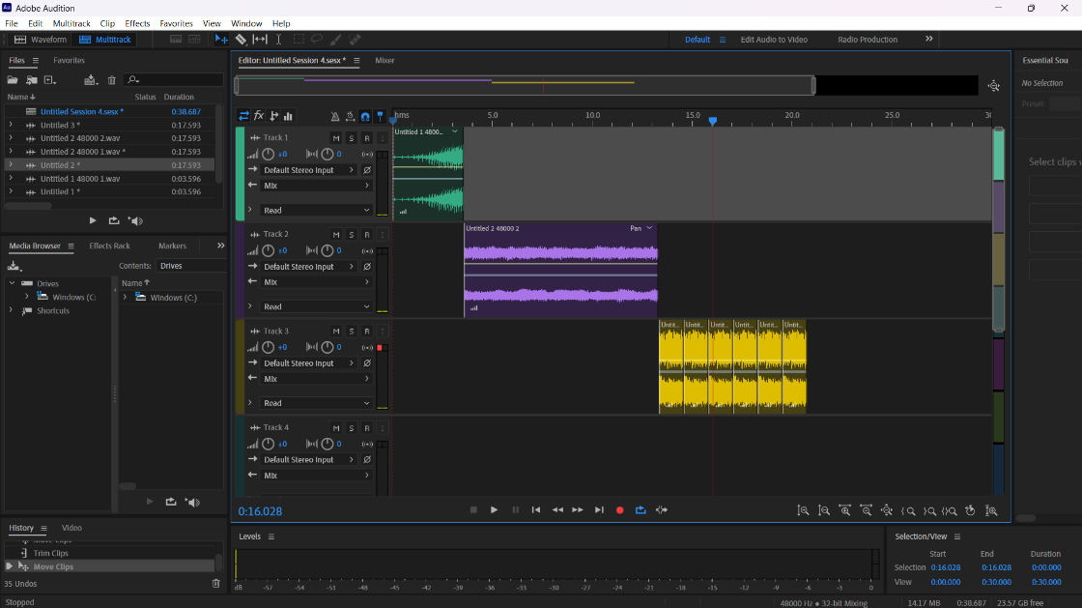

Figure 39: Cutting and merging two audio, engine start and motorboat.

UNDERWATER BACKGROUND AUDIO  
This audio was used for the submarine to simulate an actual sound when it’s submerged and navigating underwater to add more realism to the game.

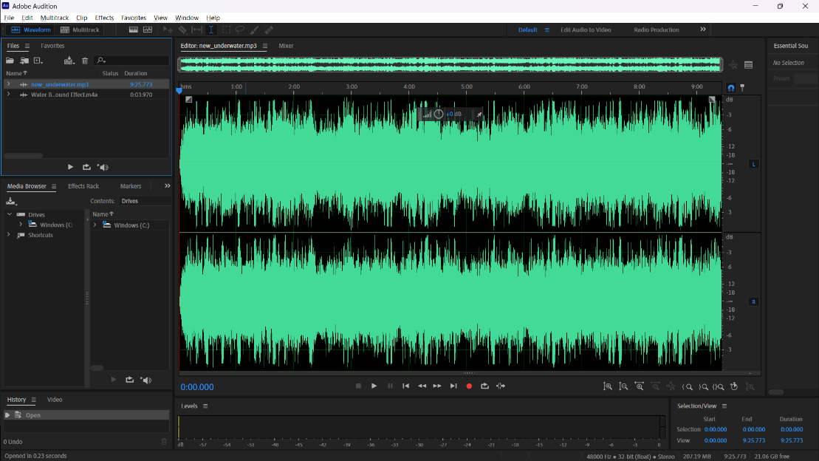[U](https://www.youtube.com/watch?v=la_AEFO8m7U)NDERWATER BACKGROUND + BUBBLE SFX MIX  
Cut and Merged two different audios, to create an entirely new one to be used in our setting, credits and select level screen to match the background.

WHALE SFX  
The whale sfx was added as a bonus audio as it plays randomly, to further increase the immersiveness of the game.

Figure 40: Underwater and bubble merged into one audio.

EPIC ADVENTURE CINEMATIC BY INFRACTION  
This audio was used in the trailer when the game starts to give a state of urgency to the player that action needs to be done and as soon as possible to protect the marine ecosystem.

GAME FEATURES

## ADMOB

In "Trash Hunter: Submarine Edition," AdMob integration improves the gaming experience by introducing non-intrusive adverts. AdMob effortlessly integrates advertising at appropriate points throughout the game, delivering a balanced strategy that does not disturb gameplay while also allowing players to engage with relevant material.

This ad monetization method helps to ensure the game's long-term viability by producing income while allowing gamers to play for free. AdMob's inconspicuous nature preserves the immersive quality of the gaming experience, establishing a balance between giving value to players and supporting game development.

Overall, the use of AdMob in "Trash Hunter: Submarine Edition" demonstrates a sensible approach to in-game advertising, which contributes to the game's financial viability while maintaining user enjoyment and engagement.

### PROCESS OF ADMOB

To integrate adverts into the game, first create an AdMob account. Next, create an app on AdMob and configure ad units to incorporate interstitial advertisements. Proceed to the Construct platform and insert the advertising into the game using the "Mobile Advert" object. Include the Android app ID in the item.

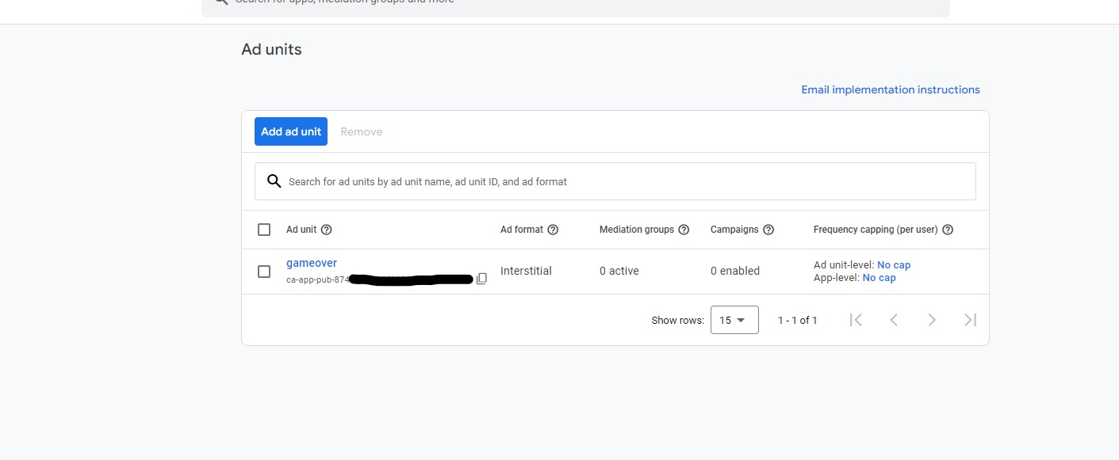  
  
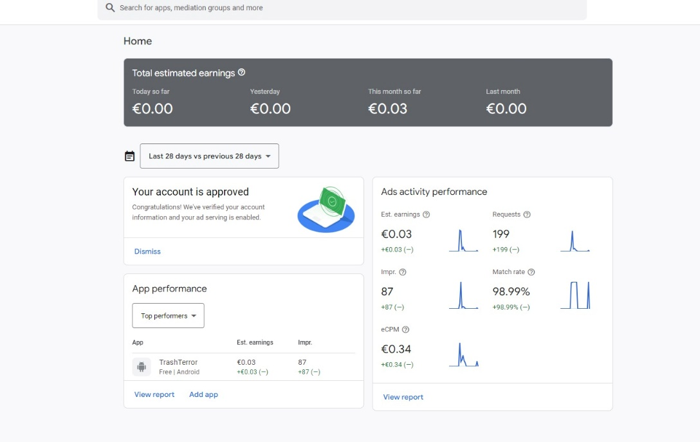Different options for the Ad unit provided by Admob for advertisement management.

Figure 41: Ad unit, types of ads and ads ID (Interstitial Ads)

Figure 42: Statistics earning for the last 28 days.

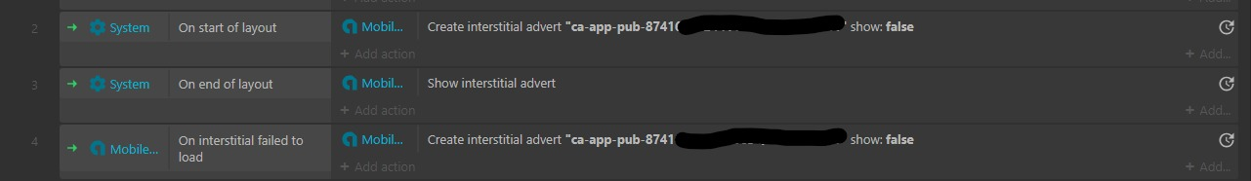Creating MobileAdvert as an object type in contruct 3 to setup interstital advertising for the game.  
  
  
Implementing interstital advertising in construct 3 when a layout starts.

Figure 43: Creating and loading of Advert (Blurred due to security reasons).

Implementation of advertisement after deployment.

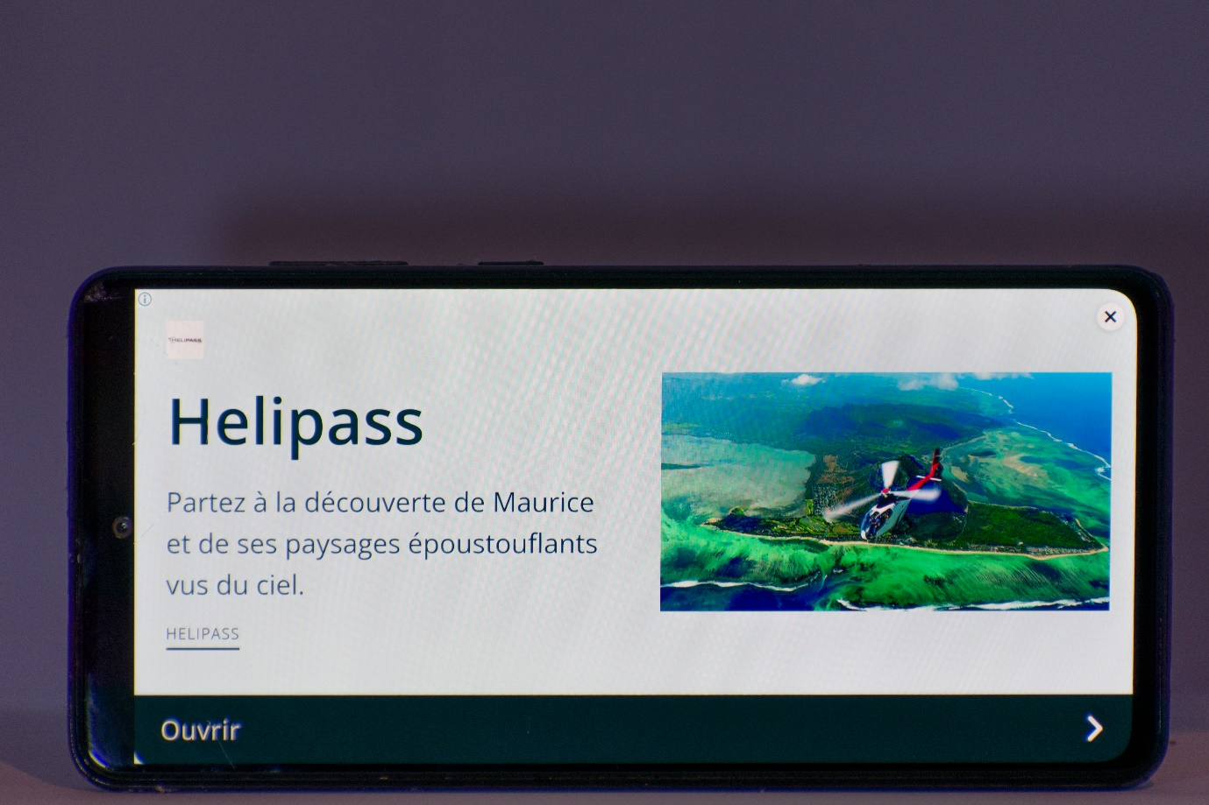

Figure 44: Final & Working Advertisement on mobile.

Figure 45 shows the analytics to the advertisement revenue that is rightfully linked to our team member Fabrice Manikon’s account.

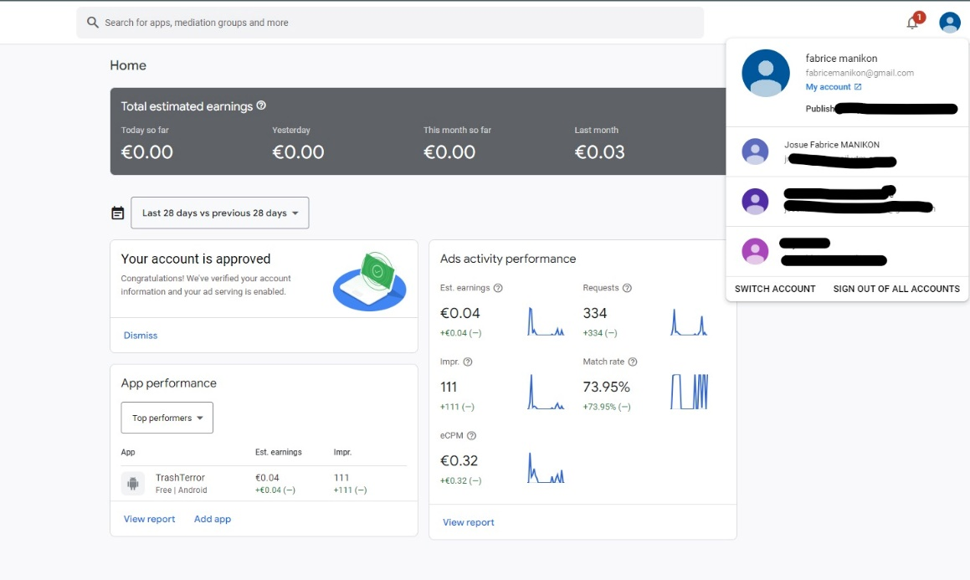

Figure 45: Proof of account.

## SINGLE SIGN ON

Single Sign-On (SSO) is implemented in "Trash Hunter: Submarine Edition," which streamlines the player's experience by delivering a seamless and speedy authentication process. SSO allows users to use a single set of credentials to enter the game, eliminating the need for multiple logins.

This convenience simplifies the onboarding process while also increasing player engagement. SSO helps to improve the gaming experience by minimizing friction during the login process. Whether players move devices or return to the game after a break, SSO provides a quick and easy login, increasing accessibility and user happiness.

The addition of Single Sign-On to the game matches with modern user expectations, stressing a user-centric design that stresses efficiency and convenience of use in "Trash Hunter: Submarine Edition."

Figure 46 shows the "Release summary" page for a specific release (release final release 2) of the app "trash hunter". This page shows information about the release, such as its availability, size, and promotion details.

The release was made available to internal testers on February 5, 2023, at 11:26 PM and is currently available on 0 devices.

The "Release delivery" section shows information about the size of the app for new installs and updates.

The "Promote release" section shows a button to promote the release and a link to view the track of the release. The percentage of the install base on this release is currently 0.00%, which means that no users have installed this release yet.

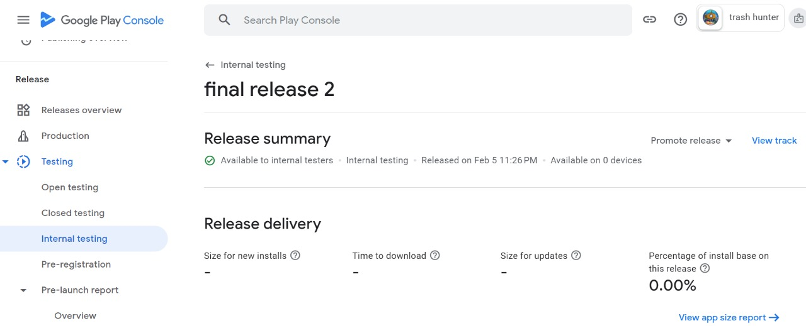

Figure 46: Final release for internal testing.

Figure 47 shows the "Releases overview" page for the app "trash hunter". This page shows the different release tracks for the app and allows developers to manage and release test and production versions of the app.

The "Production" track is where the app is available for all users to download and install from the Google Play Store.

The "Open testing" track allows developers to release a test version of the app to a large group of testers.

The "Closed testing" track allows developers to release a test version of the app to a smaller, more controlled group of testers.

The "Internal testing" track allows developers to release a test version of the app to a small group of testers within their organization.

The third picture is a continuation of the second picture, showing more information about the "Closed testing" track for the app "trash hunter".

*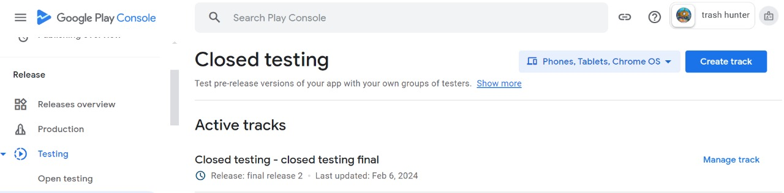*

Figure 47: Close testing.

The closed testing track is currently active and has 1 release (final release 2) which was last updated on February 6, 2024.

The "Manage track" button allows developers to manage the settings and configurations for the closed testing track.

The "View release details" button allows developers to view more information about the specific release.

The "Create release" button allows developers to create a new release for the closed testing track.

The "Download APK" button allows developers to download the APK (Android Package Kit) file for the release, which can be used to install the app on a device for testing.

The "End track" button allows developers to end the closed testing track, which will remove the release from the track and prevent any new testers from joining.

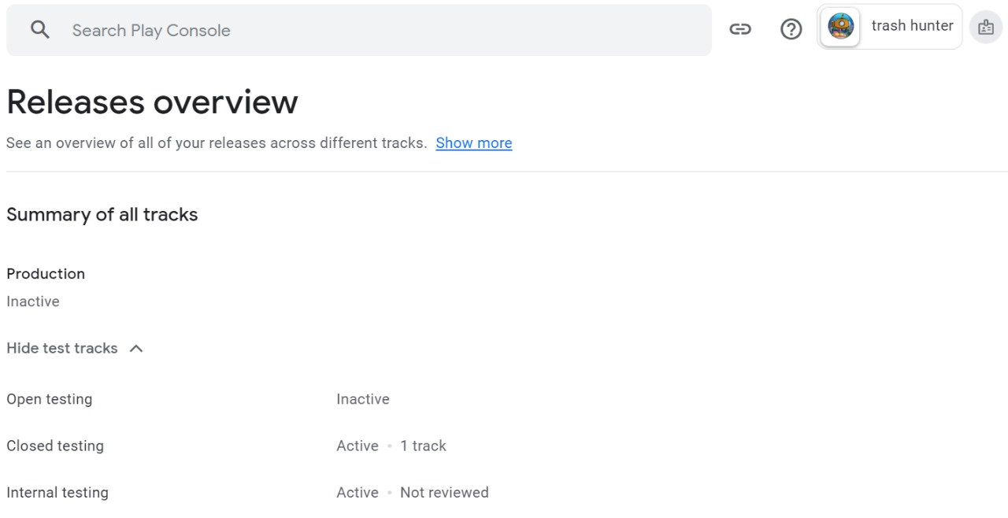

Figure 48: Releases overview.

In summary, the three pictures show different pages in the Google Play Console that developers use to manage their Android apps. The first picture shows the "Release summary" page for a specific release of the app, the second picture shows the "Releases overview" page for the app, and the third picture shows detailed information about the closed testing track for the app. These pages allow developers to manage and release test and production versions of the app, view release details, and add or remove testers.

# GAME CONTROLS

In any game, learning the fundamental controls is critical for players to travel and interact with the virtual world. "Trash Hunter: Submarine Edition" is no exception, with straightforward controls that improve the play experience.

In this undersea adventure, players use simple controls to pilot the Abyssal Ranger submarine and communicate with the support boat. The space bar has two functions: it allows players to remove and enter the submarine from the boat, providing freedom in movement and strategic decision-making.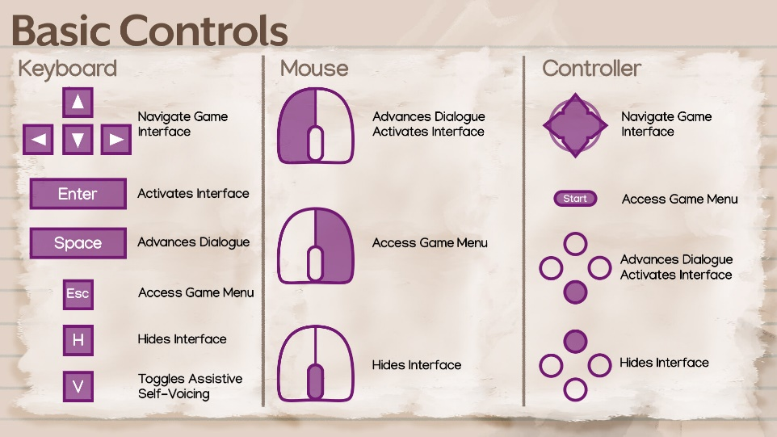

Figure 49: Keymapping overview.

## Game CONTROLS USED IN THE GAME

The easy design in our game allows players to smoothly control the submarine's motions and activities, which improves the entire gaming experience. Let us break down the functionality of each control.

### Arrow Keys:

**Up Arrow:** Moves the submarine upward. This control allows players to explore the aquatic environment and gain higher levels.

**Down Arrow:** Submerges the submarine, allowing players to explore deeper into the underwater realm.

**Left Arrow:** Moves the submarine to the left, allowing for precision navigation and avoiding obstructions.

**Right Arrow:** Moves the submarine to the right, allowing for smooth navigation across the undersea landscape.

**Mouse Controls:**

The left click initiates the claw's aiming mechanism. By clicking and holding the left mouse button, players can guide the submarine's claw at specific objects, such as trash or collectibles.

Right-clicking activates the claw, allowing you to grab or interact with things in the surroundings. Players can strategically use the claw to pick up rubbish and fulfill tasks in the game.

**Space Bar:**

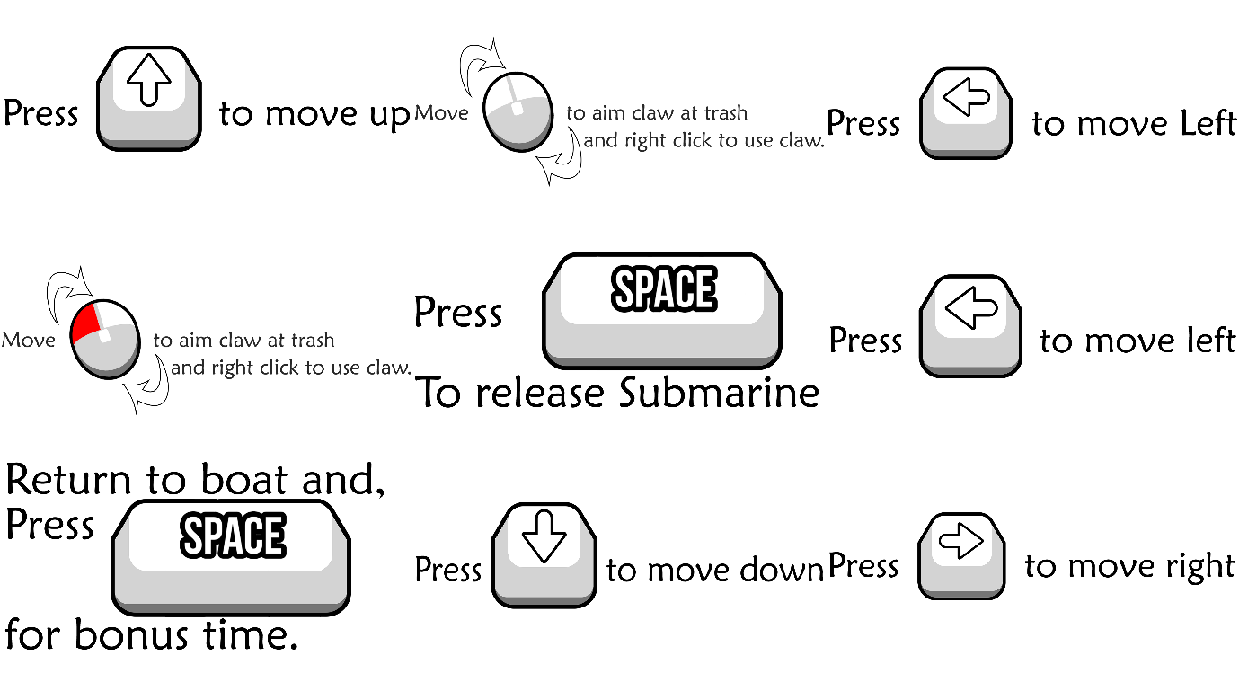The Space Bar releases the submarine's claw and returns to boat, also for bonus time. This control is essential for disposing of goods or trash that the claw has picked up. It adds another element of strategy to the game, forcing players to time their releases for the best performance.

Figure 50: Controls used to navigate the submarine.

# BUTTONS

"Trash Hunter: Submarine Edition" ensures user convenience with essential buttons, including pause for temporary halts, restart for fresh opportunities, settings for customization, and a credit button for acknowledging contributors. These features empower players to control their gaming experience, customize preferences, and explore credits for a comprehensive and user-friendly gameplay session.

## GAMEPLAY BUTTONS

Figure 51: Game Buttons.

"Trash Hunter: Submarine Edition" focuses user-friendly controls by including crucial buttons that improve the entire play experience. These buttons give players easy ways to manage gameplay and navigate across many areas of the game environment:

**Play Button:** The "Play" button invites players to dive into the underwater adventure, initiating the mission to clean up the ocean.

Figure 52: Play button.

  
**Credit Button:** The "Credits" button provides recognition to contributors and enhances transparency about the game's development.

Figure 53: Credit button.

**Settings Button:** The "Settings" button allows players to customize their gaming experience, adjusting preferences such as audio, graphics, and controls.

Figure 54: Settings button.

**Modification button**: The “Modification” button opens the submarine and boat modification menu. After collecting a certain amount of trash, players will be able to upgrade the submarine, boat, and clamp’s speed to improve their gameplay.

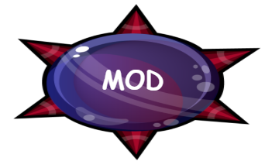

Figure 55: Mod button.

# SCREENS

## START SCREEN

The start screen of "Trash Hunter: Submarine Edition" is a comprehensive hub built for simple navigation and user engagement. The start screen provides players with a dynamic and easy entrance point into the game, featuring prominent buttons such as "Play," "Credits," and "Settings," as well as a dedicated "MOD" area.

The "Play" button invites users to dive into the undersea adventure and begin the task to clean up the ocean. The "Credits" button acknowledges contributors and increases transparency about the game's development. The "Settings" button allows users to tailor their game experience by altering audio, visuals, and controls.

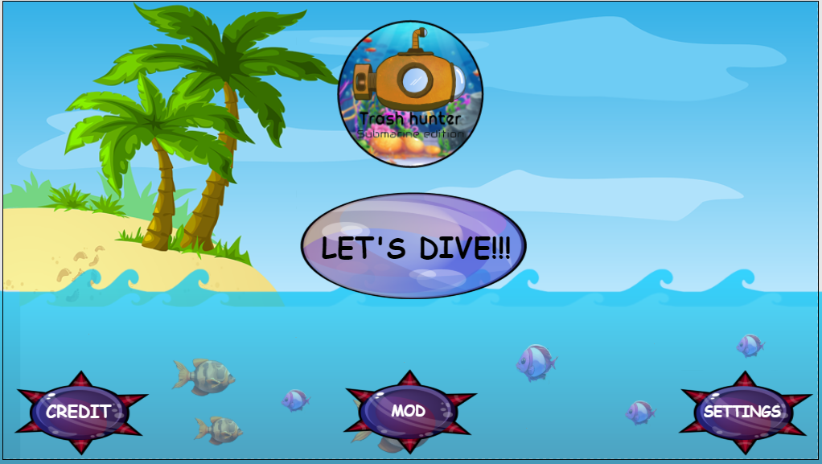The presence of a "MOD" section suggests possible modifications or more content, offering adaptability and potential growth to the gameplay. Collectively, these aspects on the start screen not only improve usability, but also show the game's devotion to player agency and a rich, personalized gameplay experience in "Trash Hunter: Submarine Edition."

Figure 56: Start Screen

## CREDIT SCREEN

The credit screen in "Trash Hunter: Submarine Edition" pays respect to the people who used their skills and imagination to bring the game to reality. This section recognizes the developers, designers, artists, and other individuals whose combined efforts helped build the immersive gaming experience.

The credit screen, which is thoughtfully designed, provides insights into the talent behind the scenes, allowing for transparency and acknowledgment. It could include names, roles, and even excerpts about each contributor's involvement in the game's production.

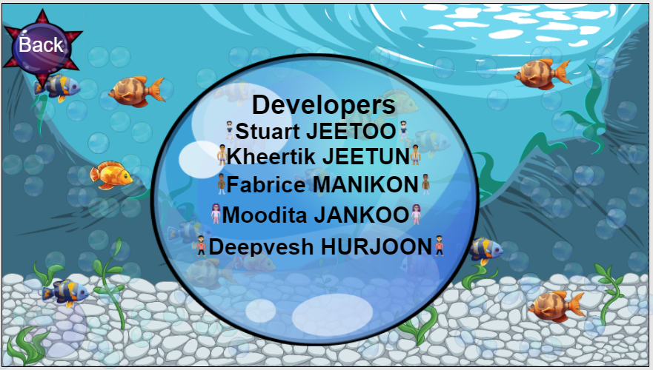By displaying the credits, "Trash Hunter: Submarine Edition" not only communicates gratitude to the team, but also encourages players to appreciate the collective effort that went into making the game. It personalizes the game experience, generating a sense of connection between players and the creative minds who brought the aquatic world to life on their screens.

Figure 57: Credit Screen.

## MOD Screen

The MOD (Modification) Screen in "Trash Hunter: Submarine Edition" is a key hub where players can improve and personalize different aspects of their gameplay experience. This feature allows players to fine-tune their equipment and add a personal touch to their undersea experience.

On the MOD screen, players can upgrade their submarine, claw, and boat with several options. These upgrades are intended to improve various aspects of gaming, allowing players to customize their equipment to fit their preferred playing style.

Upgrade your submarine to improve its speed and maneuverability underwater. This enhancement is especially useful for negotiating narrow spaces, discovering new depths, and efficiently exploring the game world.

Upgrade your claw's speed at the MOD screen to collect trash faster and more efficiently. This enhancement improves the player's ability to clean up the underwater environment fast and efficiently, making for a more enjoyable gaming experience.

Customize your boat by increasing its speed. This allows for more efficient waste disposal. A speedier boat allows for quicker travel between garbage collection stations, which improves the entire cleanup process and contributes to greater scores.

The MOD screen encourages a customizable approach to games. Players can customize their equipment based on their personal tastes, whether they value speed, efficiency, or a combination of the two. This personalization tool adds depth to the gaming experience by allowing players to strategy and optimize their equipment based on their individual playstyle.

Enhanced Pleasure and Effectiveness: By enabling a choice of adjustments, the MOD screen contributes to a more pleasurable game experience. Players will notice visible improvements in their submarine's agility, claw efficiency, and boat speed, resulting in a more interesting and gratifying gameplay experience.

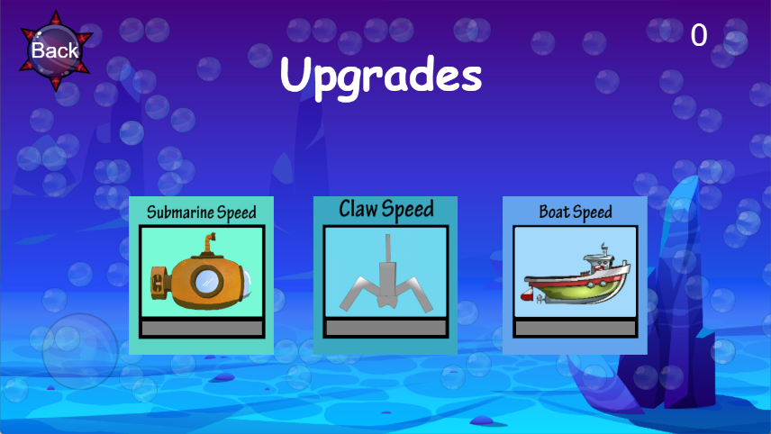To summarize, the MOD screen in "Trash Hunter: Submarine Edition" allows players to modify and customize their submarine, claw, and boat. This personalised method enables players to modify their equipment to their desired playing style, increasing the overall effectiveness and enjoyment of their underwater experience.

Figure 58: Mod Screen

## SETTINGS SCREEN

The settings panel in "Trash Hunter: Submarine Edition" provides players with three main options for customizing their gaming experience. This includes:

**Sound Options:** Players can customize the sound settings by modifying the volume levels to create an immersive and fun gameplay experience. This guarantees that the game's audio features, such as ambient sounds and effects, are consistent with individual preferences.

**Music:** The option to alter music settings allows gamers to customize the tone of their gaming experience. Whether they prefer a lively soundtrack or a more relaxing atmosphere, the music selection provides a personalized and delightful aural experience.

**Login:** The login option improves the player experience by adding a personal touch. This feature allows players to access their profiles, track achievements, and participate in multiplayer portions of the game, which fosters a sense of continuity and community.

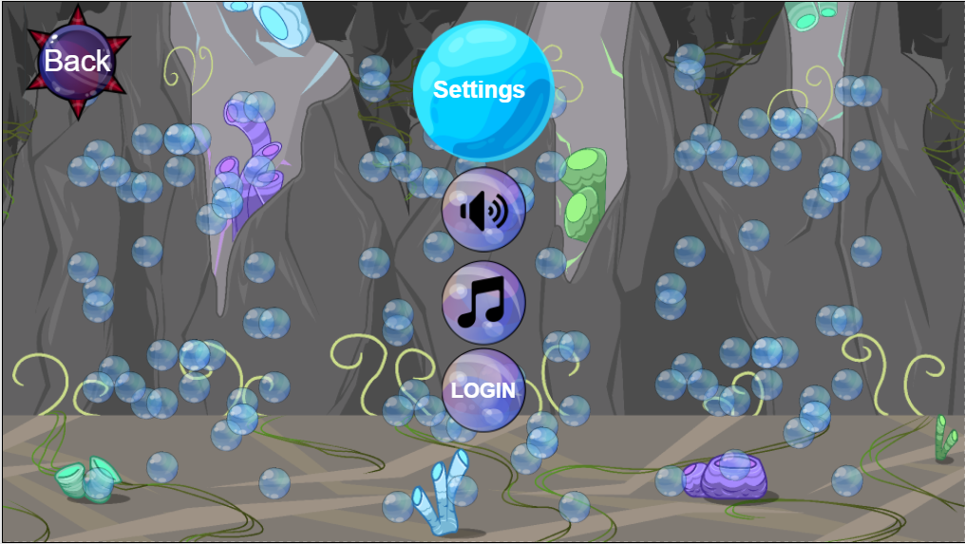

Figure 59: Settings Screen.

## SELECT LEVEL SCREEN

The Select Level screen in "Trash Hunter: Submarine Edition" has a visually appealing and intuitively built interface. With five separate levels, the inventive UI not only acts as a gateway to a variety of gaming experiences, but it also improves the overall visual attractiveness.

The carefully developed UI reflects the essence of each level, resulting in a visually distinct and entertaining environment. Each level has its own set of visuals and thematic components that give players a sense of the obstacles and locations they will face.

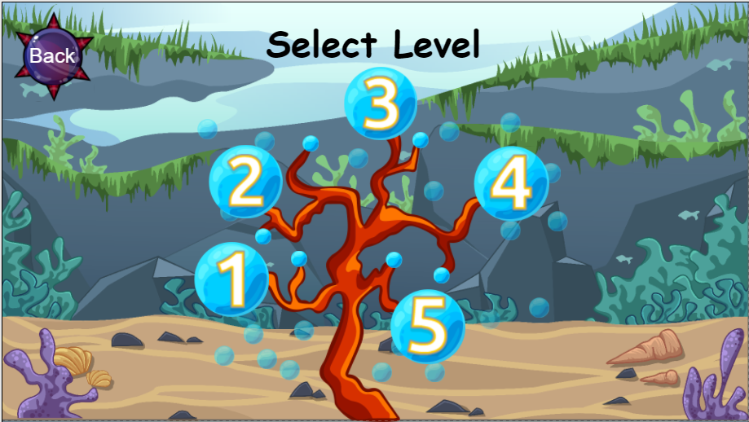The Select Level panel not only simplifies navigation but also creates a sense of suspense as players choose their gaming path. The gorgeous and imaginative user interface not only helps players through level selection but also immerses them in the thematic richness that "Trash Hunter: Submarine Edition" has to offer, resulting in an expanded and visually spectacular gameplay experience.

Figure 60: Select Level Screen

# MOBILE UI

Developing a seamless and intuitive mobile user interface (UI) for "Trash Hunter: Submarine Edition" improves the whole gaming experience, making it more accessible and interesting for users on mobile devices. Here are key considerations for the mobile UI:

## RESPONSIVE DESIGN

Ensure that the UI elements are responsive to the various screen sizes and resolutions often found on mobile devices. This adaptability guarantees that the game remains visually appealing and usable across a variety of smartphones and tablets.

## TOUCH FRIENDLY CONTROLS

Create touch-friendly controls for easy navigation. The submarine movement, claw actions, and other interactions should be optimized for touchscreens to ensure a seamless and responsive experience.

### BUTTONS IN THE MOBILE VERSION GAME

* This button facilitates the lowering and boarding of the submarine onto the boat.

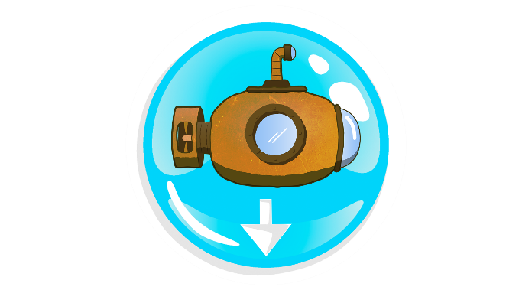

Figure 61: Drop submarine button.

* 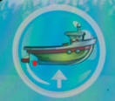This button facilitates the boarding of trash on the boat.

Figure 62: Board back on boat button.

* This button facilitates collection of trash with the claw.

Figure 63: Grab on trash button.

* 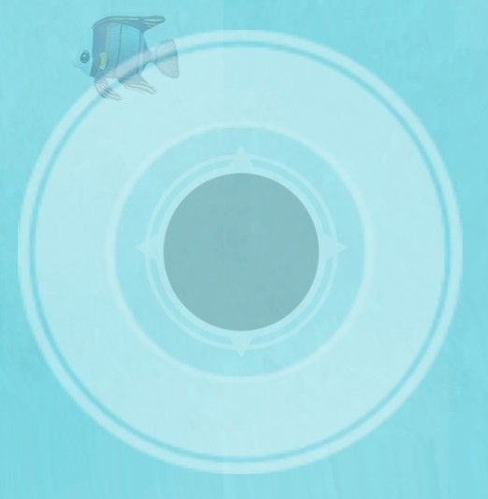This analog button helps to navigate the submarine to different places in the map.

Figure 64: Analog control button.

* This slider controls the submarine’s claw.



Figure 65: Slider to control claw.

## GAME MOBILE & TABLET INTERFACE

### UI LEVEL COMPLETE UI LEVEL

The Level Complete screen in your game provides a complete assessment of the player's performance, motivating them to strive for excellence. It contains a variety of elements that contribute to the overall assessment of their gaming. Here's a breakdown of the components on the Level Complete screen:

**Total Trash Collected:**

Displays the total amount of trash successfully collected by the player throughout the level. This statistic emphasizes the game's environmental cleanup aspect, rewarding players for their efforts to keep the undersea ecosystem clean.

**Time Spent on Level:**

Presents the duration it took for the player to complete the level. This time measure adds a sense of challenge and competition, encouraging players to increase their efficiency and finish levels faster for higher scores.

**Restart Button:**

Players can rapidly repeat the current level, allowing them to fine-tune their strategy, maximize their garbage collecting, and complete the level faster. This choice encourages a sense of constant development and mastery.

**Home Button:**

Returns the player to the main menu or game center. This button allows players to easily browse between levels, access multiple game modes, and discover extra elements within the game.

**Next Level Button:**

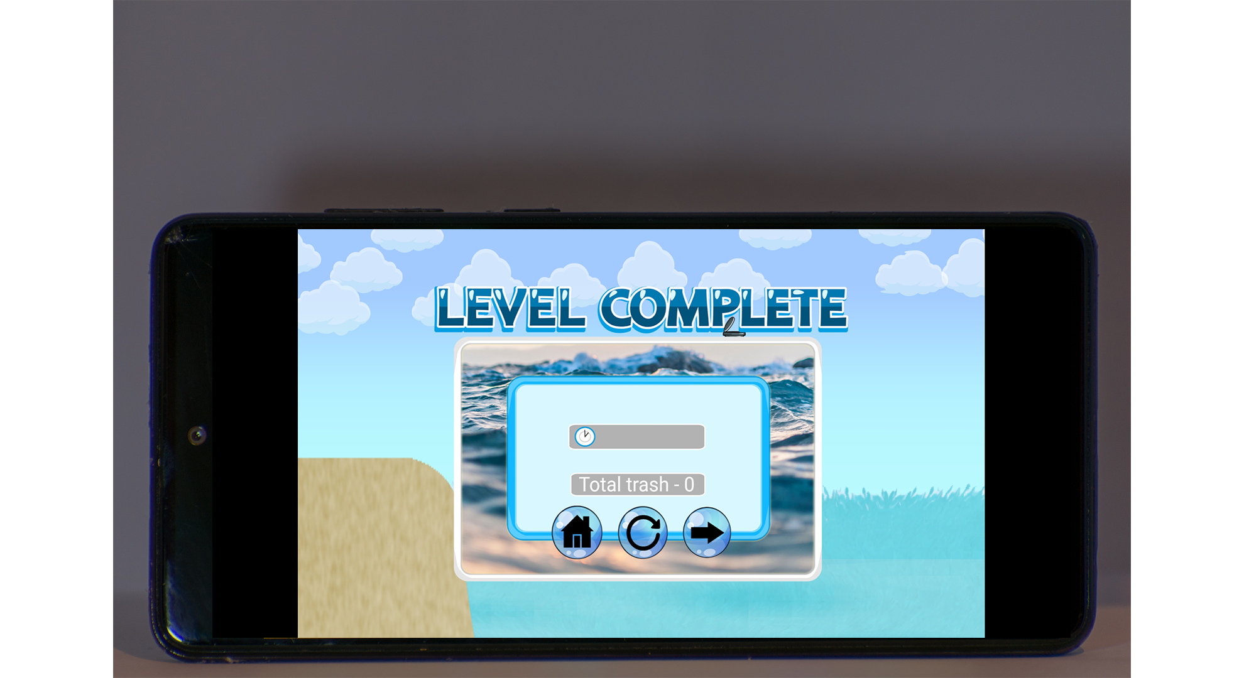Advances the player to the next level in the game. Completing a level and progressing to the next one is a gratifying and fulfilling experience for gamers. It keeps people interested and ready to discover new challenges and places in the game.

Figure 66: Level complete.

# SCREENS

### UI CREDIT SCREEN UI

The Credit Screen in "Trash Hunter: Submarine Edition" is a well-designed and meaningful part that honors the game's collaborative development. It goes beyond a mere list, including information about the roles and contributions of developers, designers, artists, and others. The credits, which include captivating images and personal passages, establish a clear connection between gamers and the creative minds behind bringing the undersea environment to life. The credit screen elevates the gaming experience by encouraging players to value the human element.

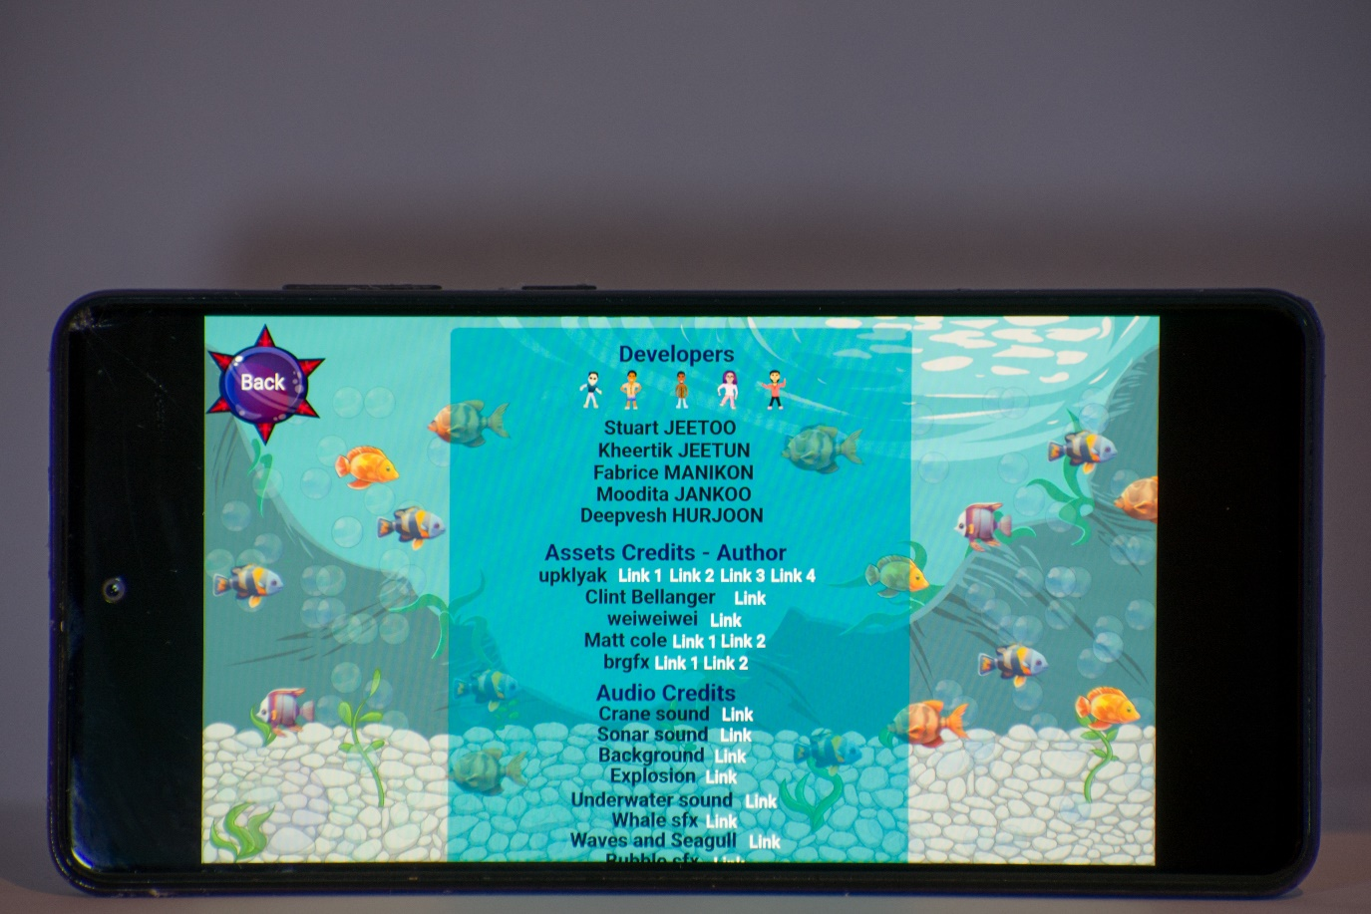

Figure 67: Credit Screen UI on phone.

### START SCREEN UI

The start screen of "Trash Hunter: Submarine Edition" is a user-friendly and entertaining hub that allows for quick navigation and player involvement. With a well-organized layout, this screen provides players with a smooth entry point into the game, emphasizing crucial features that improve usability and player agency.

The start screen features large buttons to simplify player options. The "Play" button takes center stage, urging users to dive right into the immersive underwater adventure and begin their goal to clean up the ocean. This instant call to action assures a simple and pleasurable start to the game.

The "Credits" button on the start screen acknowledges and appreciates the persons responsible for the game's production, promoting transparency. Selecting this button provides players with insights into the creative brains and abilities that brought "Trash Hunter: Submarine Edition" to existence. This acknowledgment develops a bond between players and the dedicated crew behind the game.

The "Settings" button allows gamers to customize and adapt their gaming experience based on their preferences. Users can customize audio, images, and controls to create a more personalized and comfortable gaming experience. This emphasis on customization increases user happiness while accommodating a wide range of player preferences.

The "MOD" section indicates the possibility of future content changes or additions. This not only adds adaptability to the gameplay, but also implies a commitment to future development and improvements. The presence of the "MOD" area demonstrates the game's commitment to offering players continuing chances for personalization and increased content.

The trailer button plays a video that brief the player about the sustainable goal and the urgency to create awareness to protect the marine life and its ecosystem.

The start screen elements prioritize player agency and provide a tailored gameplay experience. The strategic positioning of buttons and sections reveals a careful design that promotes user engagement and ease of use, allowing players to easily understand the game's features and go on their undersea adventure with enthusiasm.

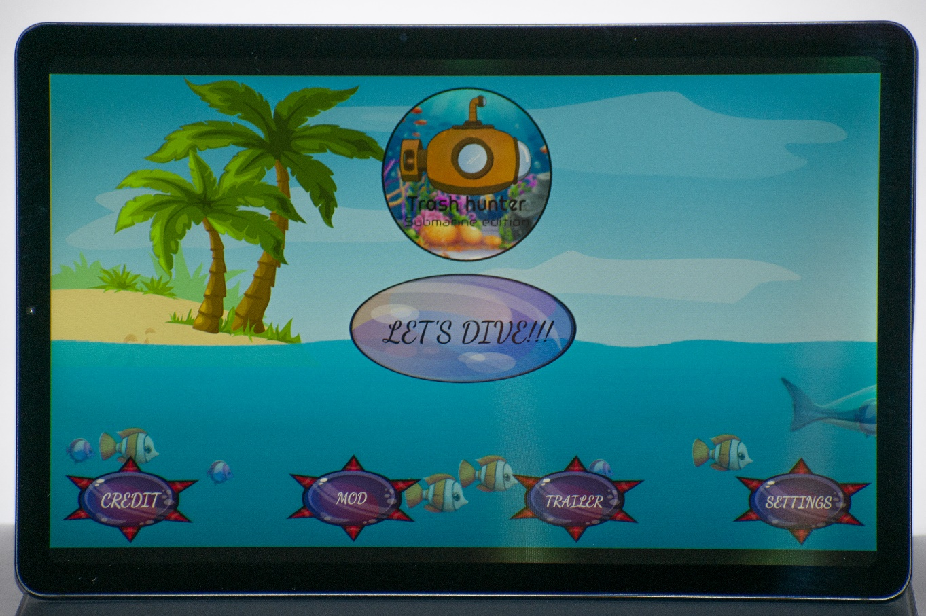In essence, "Trash Hunter: Submarine Edition"'s start screen is a well-designed center that sets the tone for a fun gaming experience. It not only allows for quick entry into the game, but it also communicates transparency, customization possibilities, and the possibility of future growth, demonstrating the game's commitment to provide players with an engaging and individualized adventure.

Figure 68: Start Screen UI on tablet.

### SELECT LEVEL SCREEN UI

The Select Level screen in "Trash Hunter: Submarine Edition" stands out for its visually beautiful and intuitive UI, which improves the overall gaming experience. With five separate levels, the imaginative user interface acts as a gateway to a variety of gaming experiences while also increasing the game's visual appeal.

The Select Level screen features a visually different interface that captures the essence of each level. The imaginative design goes beyond conventional practicality, producing a visually appealing atmosphere that piques players' interest and anticipation.

theme Representation: Visuals and theme components accompany each level on the Select Level screen, reflecting their specific challenges and places. This thematic depiction not only adds visual variation, but also gives players a preview of the difficulties and environments they will face, adding to the sense of immersion and excitement.

Simplified Navigation: The Select Level screen is both visually appealing and easy to use. Players can quickly select their desired level, making the progression through the game simple and seamless. The user-friendly interface helps to provide a smooth transition between stages, allowing players to focus on the gameplay itself.

Creating Suspense and Engagement: The Select Level screen adds suspense as players choose their game path. The visually appealing interface heightens the expectation, generating a sense of excitement and involvement. This method not only simplifies level selection, but also immerses players in the game's thematic depth, developing anticipation for the challenges ahead.

The user interface not only serves as a functional tool, but also enhances the gameplay experience. By incorporating thematic aspects and visual variation into the Select Level screen, players are transported to the universe of "Trash Hunter: Submarine Edition," laying the groundwork for an engaging and enjoyable gaming encounter.

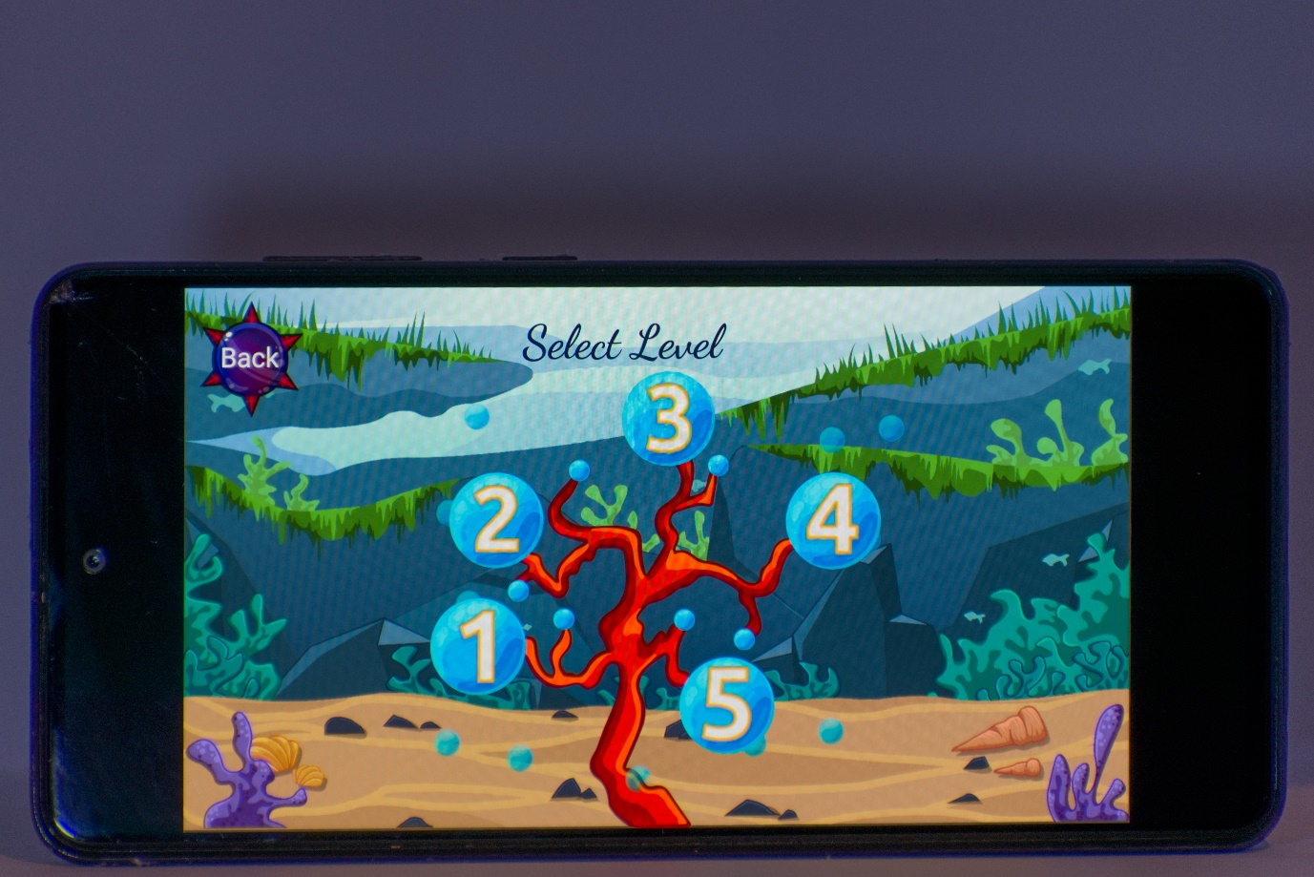In conclusion, the Select Level screen in "Trash Hunter: Submarine Edition" goes beyond its utilitarian purpose by giving players with a visually different and thematically rich interface. The innovative design not only facilitates level selection, but it also adds to overall engagement and anticipation, improving the game experience and immersing players in the enthralling realm of the undersea adventure.

Figure 69: Select level screen UI on mobile.

### SETTING SCREEN UI

The Settings Panel in "Trash Hunter: Submarine Edition" provides players with three crucial options for customizing their gaming experience, boosting both personalization and enjoyment.

**Sound Options:** Customize your audio experience by modifying the volume levels. This customisation guarantees that the game's audio features, such as ambient sounds and effects, are consistent with player preferences. Whether players prefer an immersive underwater ambiance or a more subdued experience, the ability to change sound settings adds another degree of customization, resulting in more engaging and unique gameplay.

The Music Settings feature allows gamers to customize their gaming experience by changing the soundtrack. Whether players choose a lively and energetic background or a more tranquil and relaxing atmosphere, this feature allows them to select the musical tone that best suits their playing style. The ability to personalize in-game music not only increases personalization, but it also leads to a more interesting and enjoyable gaming experience.

Adding a login option enhances the player experience by personalizing it and creating a sense of continuity. Logging in allows players to view their profiles, track their achievements, and maybe participate in multiplayer portions of the game. This feature not only increases individual involvement, but it also fosters a sense of community among players, resulting in a more connected and engaged gaming experience.

These customization options in "Trash Hunter: Submarine Edition" adapt to users' preferences, resulting in a more personalized and enjoyable gameplay experience. The option to adjust audio aspects, song choices, and profile interactions allows users to design their own adventure, ensuring that everyone’s voyage through the aquatic world is unique and extremely pleasant.

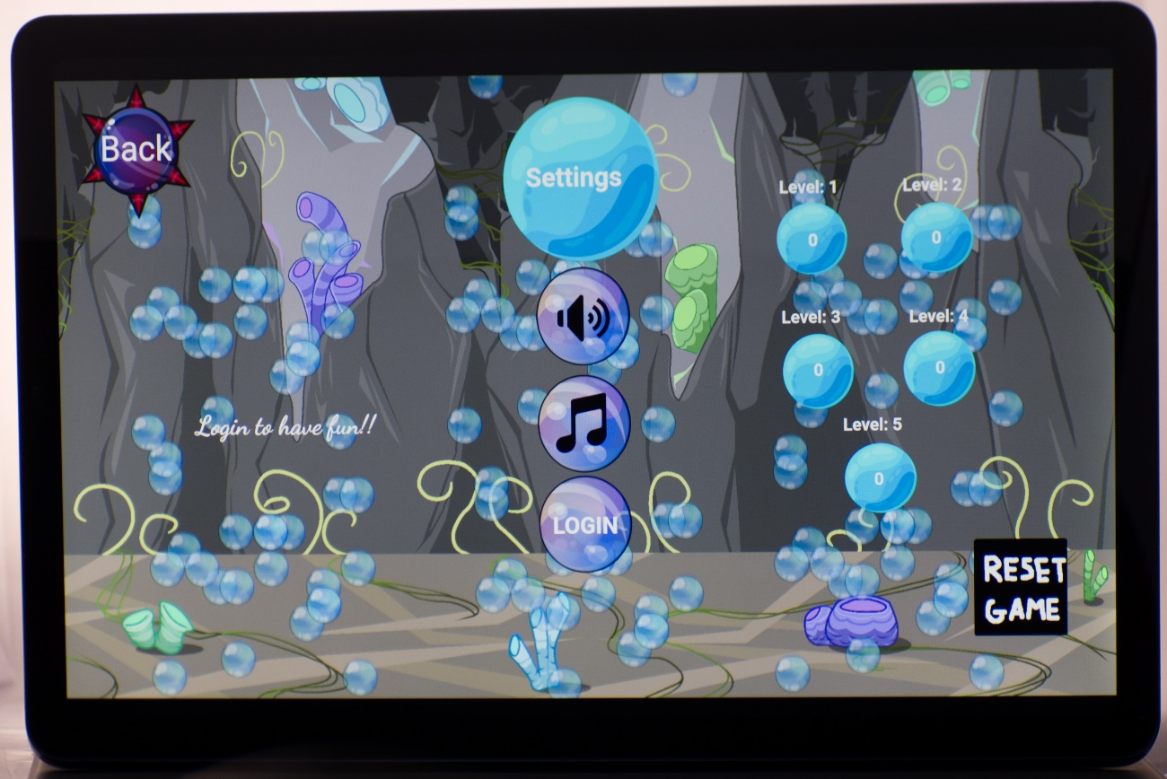

Figure 70: Settings Screen UI on tablet.

### PAUSE SCREEN UI

The Pause Screen UI in the mobile edition of "Trash Hunter: Submarine Edition" is streamlined and user-friendly, giving players easy ways to adjust their gameplay experience. Here's a breakdown of the main features on the Pause Screen.

**Resume Button:**

The "Resume" button is the most visible feature on the Pause Screen. Placed in the center of the screen, it allows players to instantly resume the game where they left off. This button is intended for rapid and intuitive interaction, ensuring a smooth transition back into gaming.

**Restart Button:**

The "Restart" button, which appears alongside the "Resume" button, allows players to restart the current level or session. This is beneficial for those who wish to attempt a new method or take on challenges without having to navigate through additional menus.

**Home Button:**

Players can return to the main menu or game hub by pressing the "Home" button, which is usually prominently displayed. This feature allows players to exit their current level and explore other sections of the game quickly and easily.

**Mute Button:**

The "Mute" button allows players to turn on and off the sound effects, giving them quick control over the audio experience. The mute button helps players to enjoy the game in a quieter atmosphere or in situations where noise is not desired.

**Music Button:**

The "Music" button, located next to the mute button, allows players to control the game's soundtrack. Tapping this button allows players to turn on or off the background music, giving them the freedom to tailor the auditory environment to their liking.

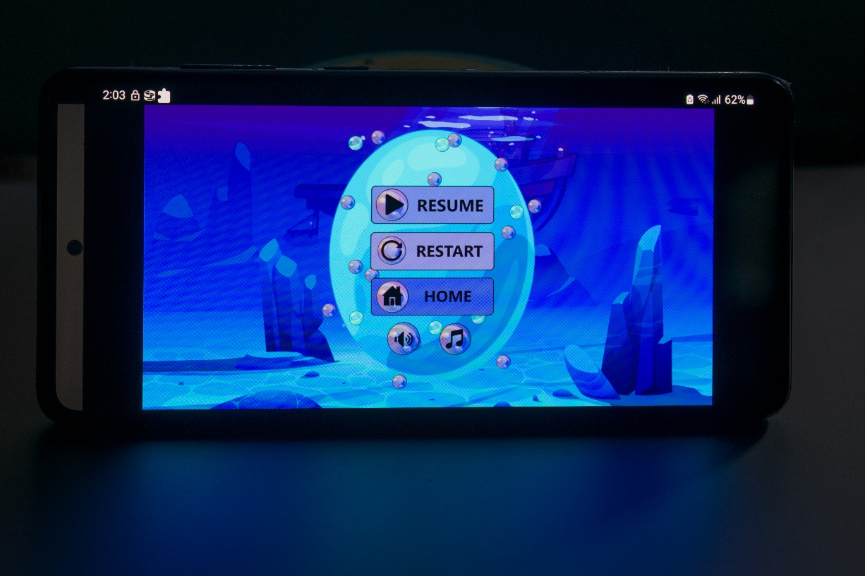

Figure 71: Pause screen UI on phone.

### MODIFICATION SCREEN

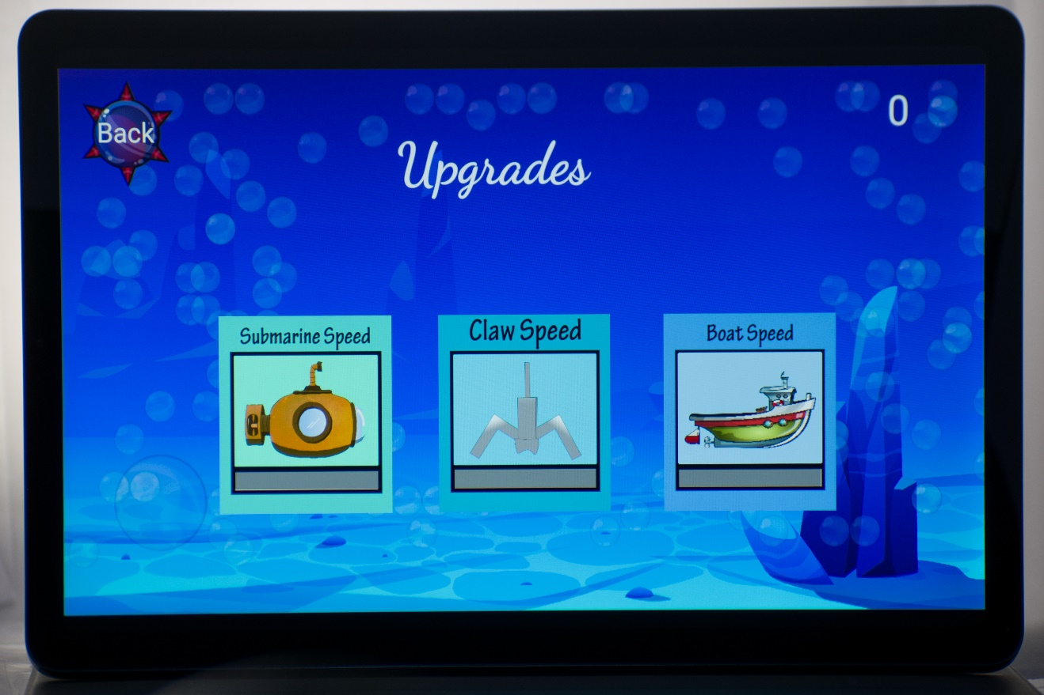The modification screen provides upgrades for the boat and submarine speed as well as upgrades for the submarine’s clamp speed. These upgrades can be unlocked after collecting a specific amount of trash. Additionally, more upgrades will improve the gameplay and increase the pace of the game, assisting the player to collect even more trash hence gaining additional time boost.

Figure 72: Modification screen UI in tablet.

### LEVEL 1 GAMEPLAY TUTORIAL

#### ON BOAT

Level gameplay when the captain is commandeering the boat, level 1 is the tutorial level where it teaches the players different controls to make the boat move. As shown in the picture, the right and left button appears.

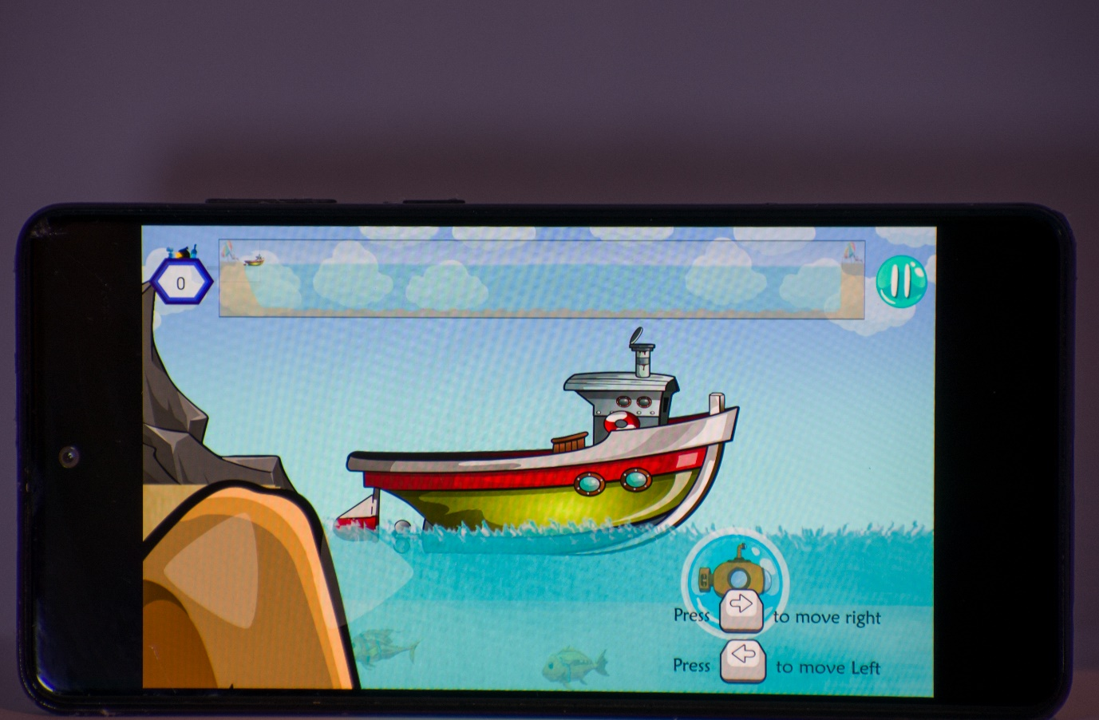

Figure 73: Level 1 boat tutorial on phone.

#### On submarine

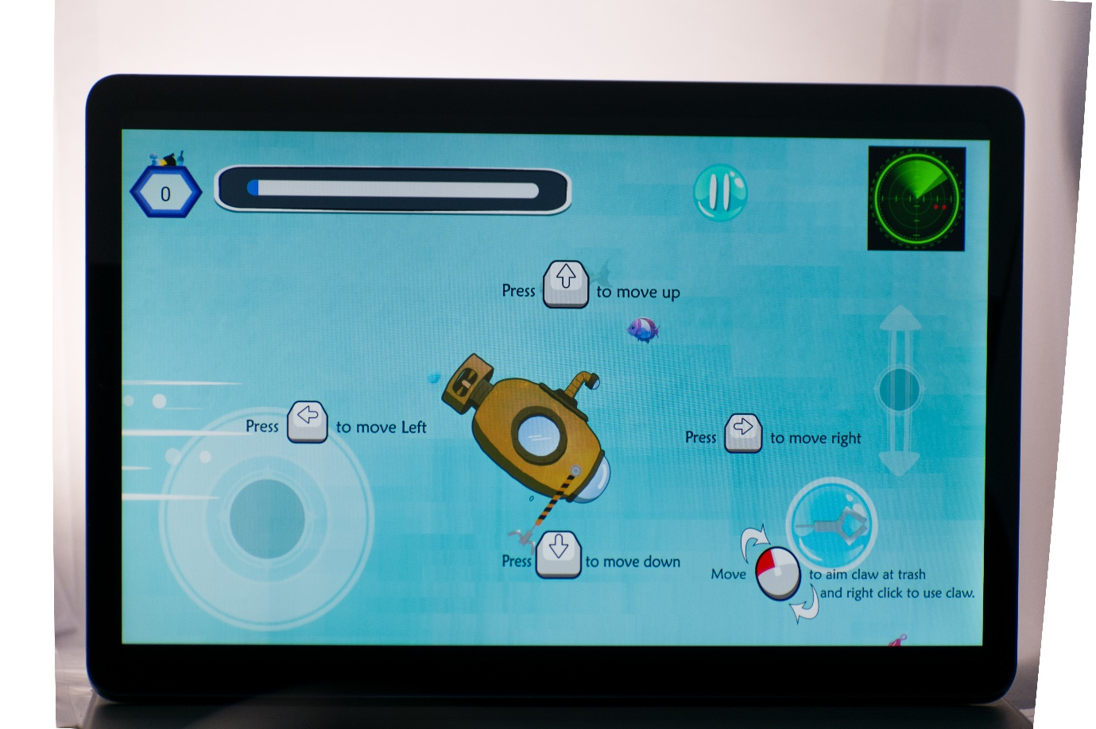After the submarine has been ejected from the boat, new controls and HUD will appear. The tutorial will show the players the different controls of the submerged submarine and will be able to navigate the underwater to carry its mission for collecting trash. Limited by a 5-minute time frame, the player must attempt to collect most of the trash before the time ends. After every successful collection, the player will be awarded with additional bonus time.

Figure 74: Level 1 submarine tutorial on tablet.

## SOCIAL MEDIA MARKETING [WEBSITE](https://65c15bfe438e030095e86cb7--vocal-axolotl-8eec77.netlify.app/) The website contains information about our game such as game story, the idea behind it, game plot and it objective to raise awareness for Sustainable Development Goal. Furthermore, google PlayStore and itch.io link has been added so that people can access and play the game on android platform and web platform easily. Moreover, a gallery was added to provide our visitors a foretaste of our game. [Google PlayStore](https://play.google.com/apps/internaltest/4700707806014205345)

Figure 75: Sustainable Development Goal Game website.

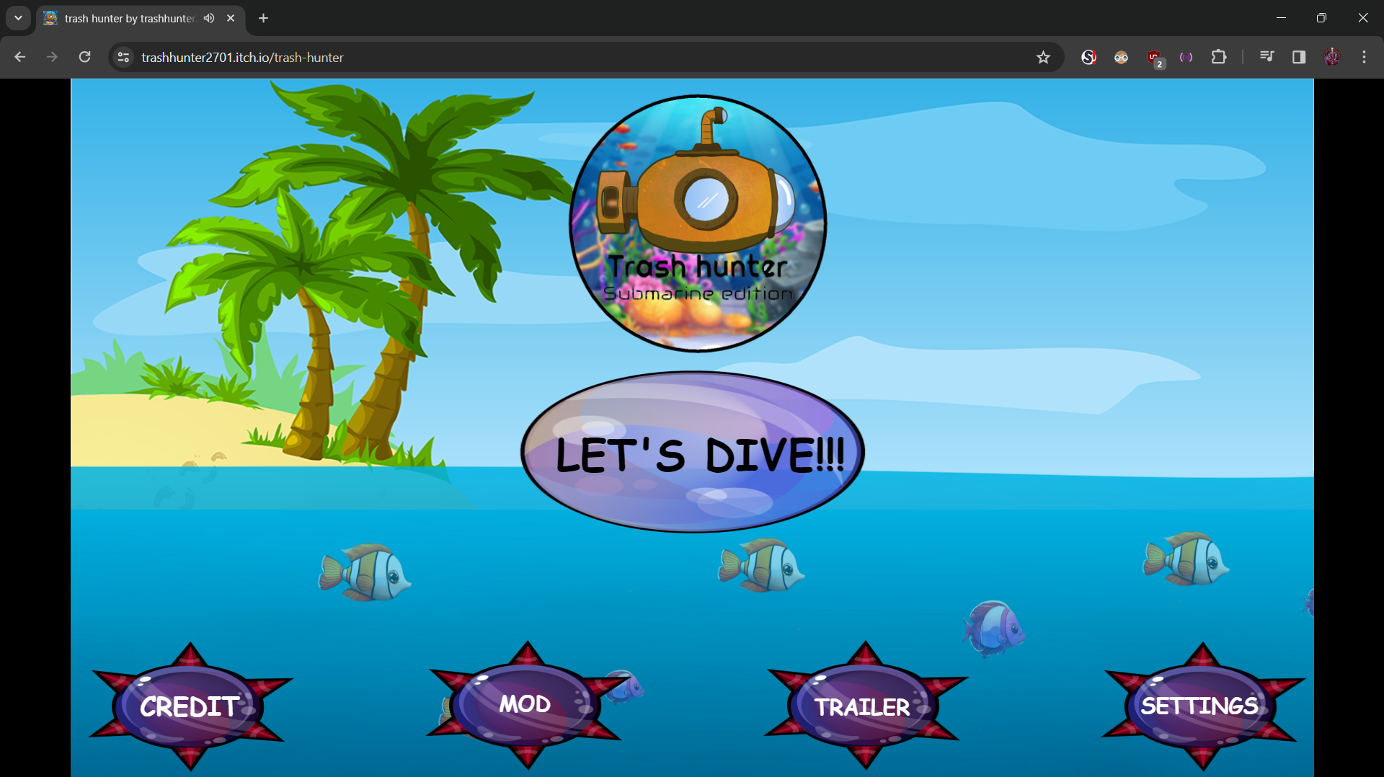  
  
We have published our game; however, it is still unreviewed since closed testing is completed yet. Once the closed testing is completed, the game will be pushed into production.  
  
[ITCH.IO](https://trashhunter2701.itch.io/trash-hunter)  
  
We have uploaded our game Trash Hunter into Itch.io game for the browser platform. Itch.io is an easily accessible medium to play games, additionally players won’t require the need to create an account to play our game.

Figure 76: Itch.io Browser game.

Figure 77: Google PlayStore (Unreviewed)

[Facebook](https://www.facebook.com/profile.php?id=61556070937905)  
  
  
  
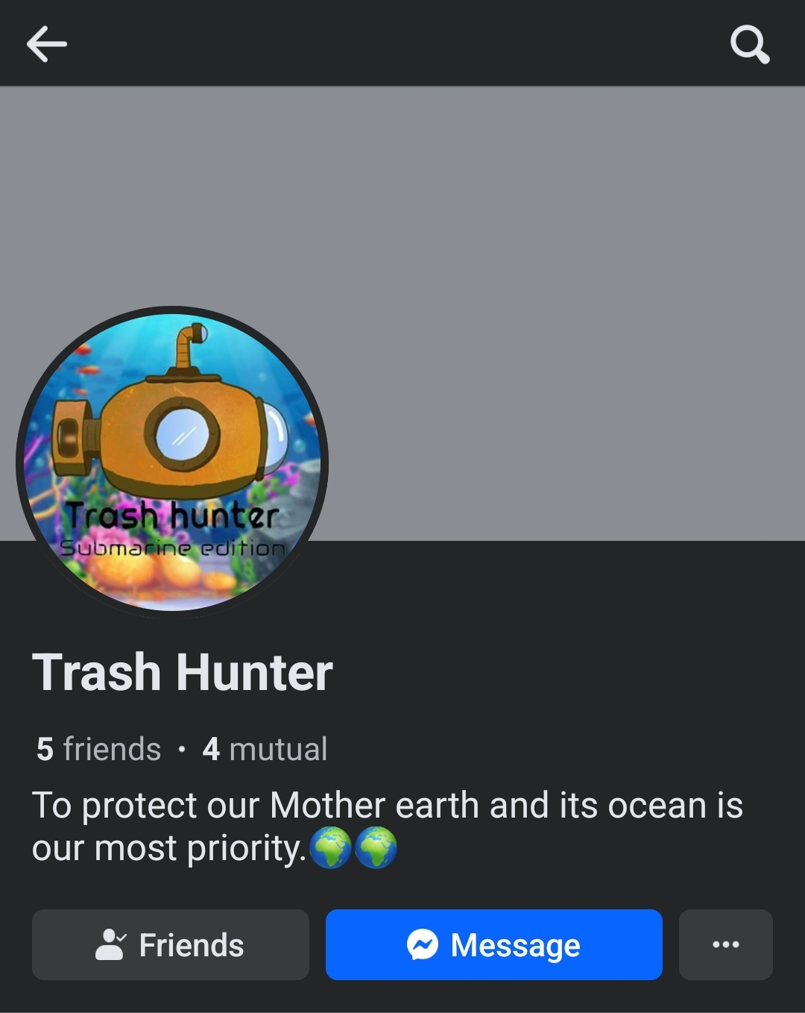We have created a Facebook account for our game, so that it will be able to reach more people to raise awareness about the state of marine life.

Figure 78: Facebook account for our game.

## [Instagram](https://www.instagram.com/trashhunter2701?igsh=MXV1YTFyZ3NtMHEz) Our Instagram account, has already accumulated a few followers and more to come. This support motivates us as it shows that our game interested a few people.

Figure 79: Instagram account for our game.

## [YouTube](https://www.youtube.com/@TrashHunter-ou8co)

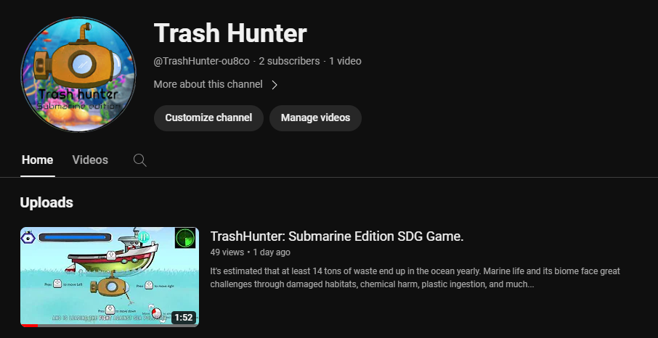We have released our trailer on our YouTube channel and there is more to come.

Figure 80: YouTube Channel for our game.

# A screenshot of a video game Description automatically generatedGAME POSTER

Figure 81:Game poster

# REFERENCES

## IMAGE ASSETS AND PACKS

CRAFTPIX for “free underwater world 2D game objects”. - [Link](https://craftpix.net/freebies/free-underwater-world-2d-game-objects/)

CRAFTPIX for “free underwater world parallax game backgrounds”. - [Link](https://craftpix.net/freebies/free-underwater-world-parallax-game-backgrounds/)

PngWing for free submarine picture. - [Link](https://www.pngwing.com/en/free-png-nudbr)

FREEPIK for publishing user upklyak’s work called “pollution sea by plastic trash, garbage underwater” and “Underwater landscape with sea life animals”. - [Link](https://www.freepik.com/free-vector/pollution-sea-by-plastic-trash-garbage-underwater_7588868.htm), - [Link](https://www.freepik.com/free-vector/underwater-landscape-with-sea-life-animals_6993843.htm" \l "from_view=detail_alsolike)

OpenGameArt for publishing author Clint Bellanger’s work for “pixel art items for a game about recycling”. - [Link](https://opengameart.org/content/recycle-items-set)

PngTree for publishing author weiweiwei’s work called “black and white plastic bags”. - [Link](https://pngtree.com/freepng/black-and-white-plastic-bags_3006022.html)

Vecteezy for publishing author Matt Cole’s work called “set of plastic trash” and “different types of trash and trashbags”. – [Link](https://www.vecteezy.com/vector-art/372944-set-of-plastic-trash), - [Link](https://www.vecteezy.com/vector-art/295374-different-types-of-trash-and-trashbags)

FREEPIK for publishing user brgfx’s work called “a wall made of stone”, “set granite stones isolated white” and “set of gray stones isolated on white”. – [Link](https://www.freepik.com/free-vector/wall-made-stone_1502993.htm" \l "query=rock%20surface&position=19&from_view=search&track=ais&uuid=2d90eb29-722e-4682-ac6d-db898f30c6ae), - [Link](https://www.freepik.com/free-vector/set-granite-stones-isolated-white_13774193.htm), - [Link](https://www.freepik.com/free-vector/set-gray-stones-isolated-white_16856094.htm" \l "query=set-gray&position=5&from_view=author&uuid=3eae88df-4c83-4213-a921-fa0b638360bd)

OpenGameArt for publishing author Brett Post Script’s work called “PC keyboard, mouse touch input icons”. – [Link](https://opengameart.org/content/pc-keyboard-mouse-and-touch-input-icons)

Game Developer Studio for publishing artist Robert Brooks’s work called “Dash effect” and “Boat two”. – [Link](https://www.gamedeveloperstudio.com/graphics/viewgraphic.php?page-name=Dash-effect&item=19657a15503p9g465c), - [Link](https://www.gamedeveloperstudio.com/graphics/viewgraphic.php?page-name=Boat-two&item=1l4x3s1p74847j3g41)

PngTree for publishing user tree’s work called “The ocean has so many trashes and plastic covered around in it background”, “Boat is in the middle of the ocean covered with plastic and waste background” and “Plastic items are floating in the water off of Vietnam background”. – [Link](https://pngtree.com/freebackground/the-ocean-has-so-many-trash-and-plastic-covered-around-in-it_3395297.html), - [Link](https://pngtree.com/freebackground/boat-is-in-the-middle-of-the-ocean-covered-with-plastic-and-waste_3397530.html), - [Link](https://pngtree.com/freebackground/plastic-items-are-floating-in-the-water-off-of-vietnam_3164771.html)

FREEPIX for publishing user rorozoa’s work called “Plastic waste quietly gathers in the ocean unnoticed by marine life”. - [Link](https://www.freepik.com/free-photo/plastic-waste-quietly-gathers-ocean-unnoticed-by-marine-life_135009193.htm" \l "query=sea%20pollution&position=5&from_view=search&track=ais&uuid=0fa703f3-7f31-496e-9d47-da9f25f7edb4)

FREEPIX for publishing user jcomp’s work called “Trash on sand beach showing environmental pollution problem”. - [Link](https://www.freepik.com/free-photo/trash-sand-beach-showing-environmental-pollution-problem_3805894.htm" \l "query=sea%20pollution&position=1&from_view=search&track=ais&uuid=0fa703f3-7f31-496e-9d47-da9f25f7edb4)

CRAFTPIX for “Island game – free GUI” - [Link](https://craftpix.net/freebies/island-game-gui/)

FREEPIX for “Free vector hand drawn animations frames element collection”. - [Link](https://www.freepik.com/free-vector/hand-drawn-animation-frames-element-collection_32376918.htm" \l "query=game%20assets%20bubble&position=3&from_view=keyword&track=ais&uuid=e15fc804-69e4-4f0f-b2b8-7533155a9d92)

Wallpapers.com for publishing artist scasati’s work called “A powerful volcano illuminated by the sun”. - [Link](https://wallpapers.com/background/volcano-background-eea0xgtjs3xob6sn.html)

Shutterstock for publishing artist klyaksun’s work called “Hot liquid lava puddle fx with orange bubble 2d. Volcano liquid magma fire for game hell environment”. - [Link](https://www.shutterstock.com/image-vector/hot-liquid-lava-puddle-fx-orange-2303681235)

CRAFTPIX for “Free Flame effects sprite packs”. - [Link](https://craftpix.net/freebies/free-flame-effects-sprite-pack/)

## SOUND

User Asleep in perfection for publishing their work on YouTube called “Peaceful underwater sounds for deep sleep, deep ocean ASMR/Ambience”. – [Link](https://www.youtube.com/watch?v=la_AEFO8m7U)

User Sounds of Nature and Beyond for publishing their work on YouTube called “Relax or study with nature sounds: Waves and Gulls with 1 hr”. - [Link](https://www.youtube.com/watch?v=HKmEWRZNJ3k)

User Free Music Collection for publishing their work on YouTube called “Water Bubble Sound Effect”. - [Link](https://www.youtube.com/watch?v=NALg_oqdg_Y)

Storyblocks for publishing a sound effect asset called “Big Engine Start”, Idle of Asset ID: SBA-300024399. - [Link](https://www.storyblocks.com/audio/stock/big-engine-start-idle-rgcm2so3uwbk0wxow07.html)

Pixabay for publishing a sound effect asset called “Motorboatsound”. - [Link](https://pixabay.com/sound-effects/motorboatsound-32776/)

User Infraction – No Copyright Music for publishing their work on YouTube called “Epic Adventure Cinematic Music by Infraction [No Copyright Music] / Vega”. - [Link](https://www.youtube.com/watch?v=HvtIGihCGUE)

View all the assets with their respective licenses in [GitHub](https://github.com/stuartjeet122/gaming-assets-2).